Part 1: Creating the Virtual Machine in VMware Workstation
Step 1: Launch VMware Workstation Pro and click on Create a New Virtual Machine.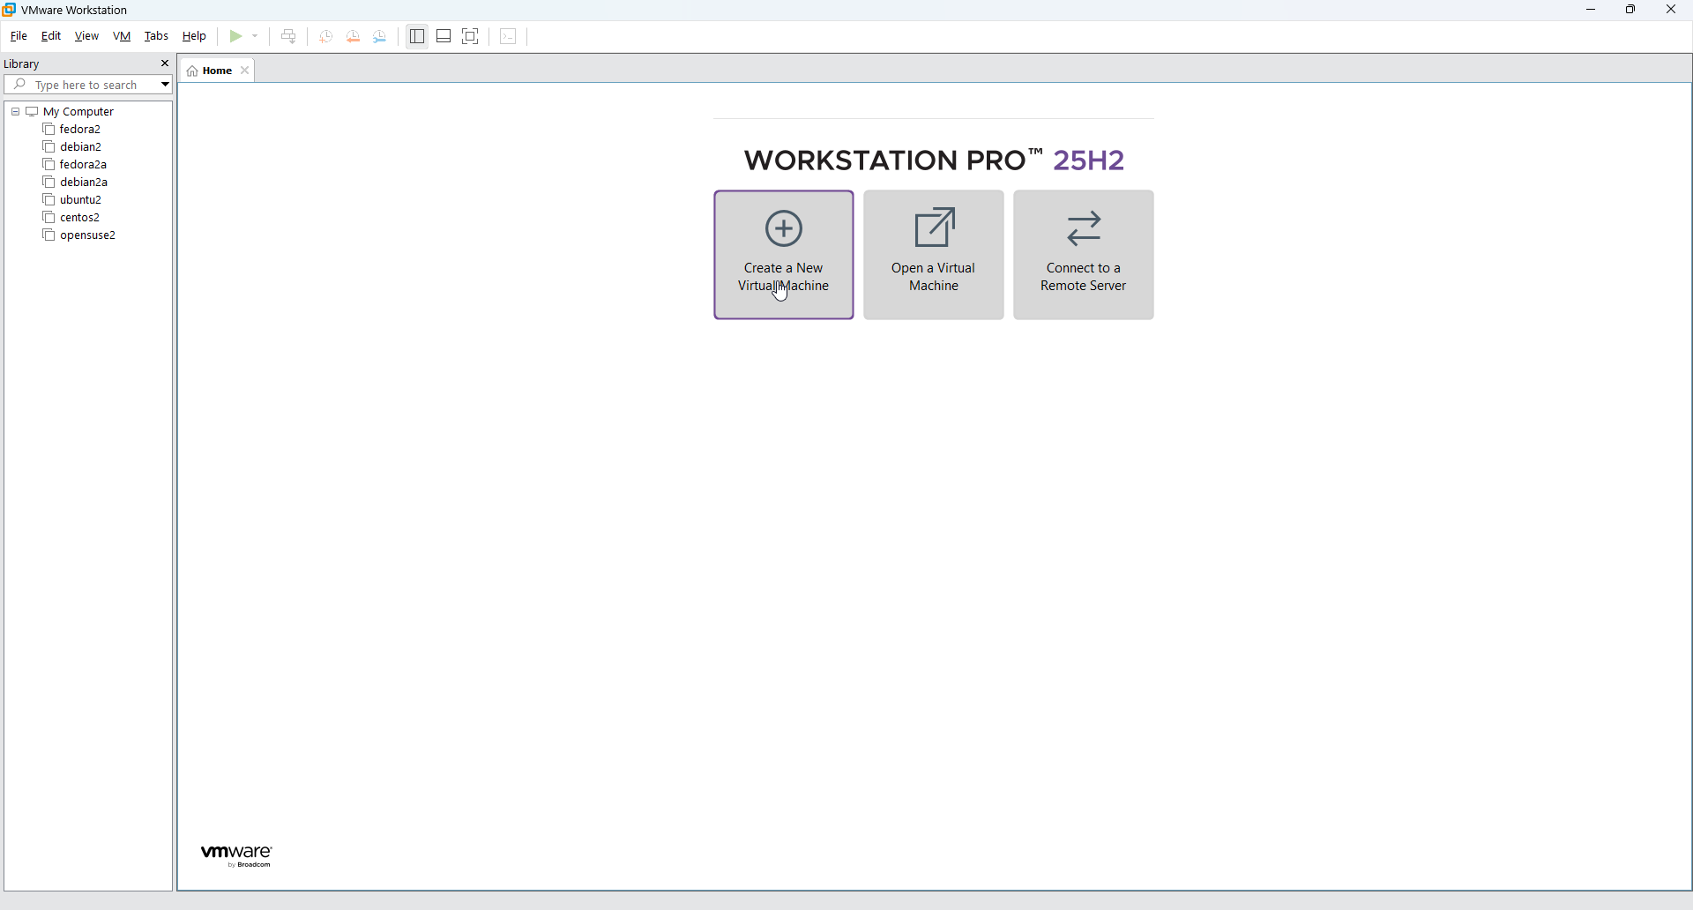
Step 2: When the wizard opens, choose the Typical (recommended) configuration type and click Next. 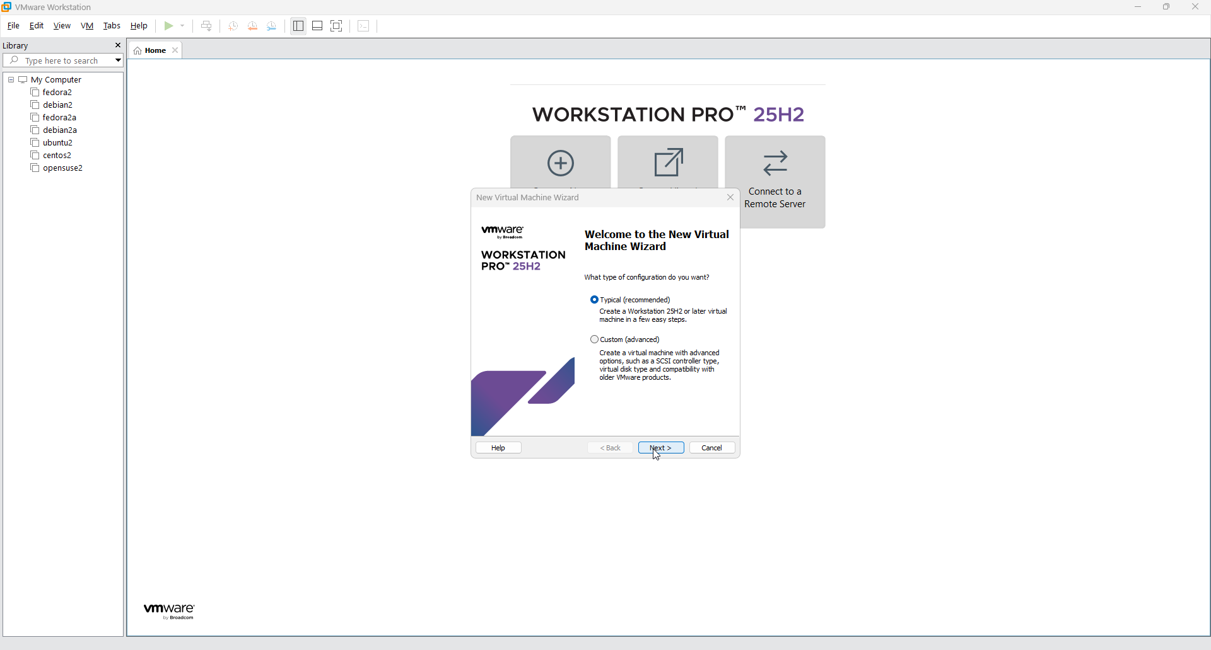
Step 3: For the installation media, select "I will install the operating system later" and proceed. 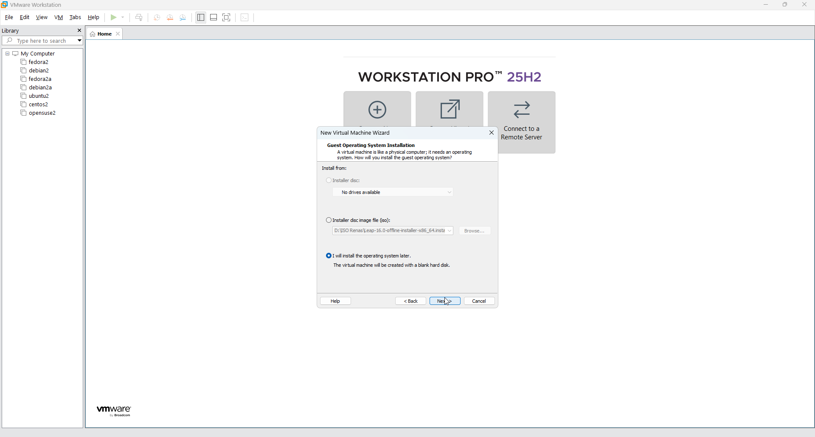

- When prompted to specify the disk capacity, set the Maximum disk size to 60 GB and select "Split virtual disk into multiple files".
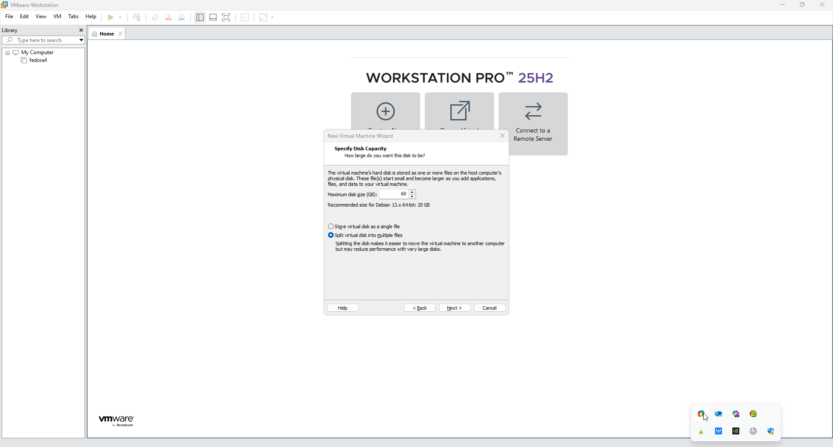
- On the final summary screen (which lists the VM name as "debian4"), click the "Customize Hardware..." button before finishing.
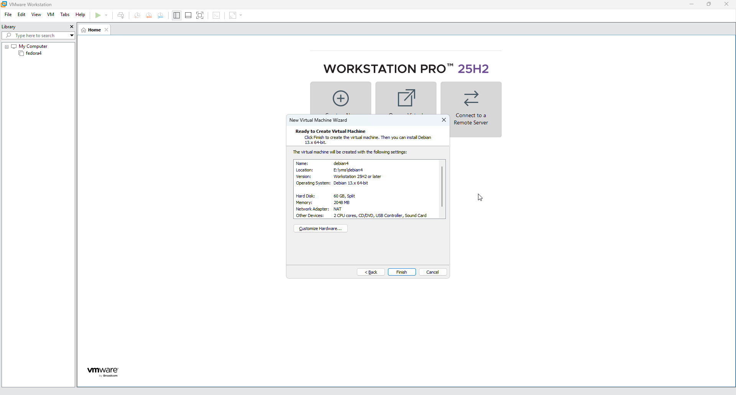
Phase 2: Customizing Virtual Machine Hardware
- In the Hardware window, select Memory and allocate 8 GB (8192 MB) to the virtual machine.
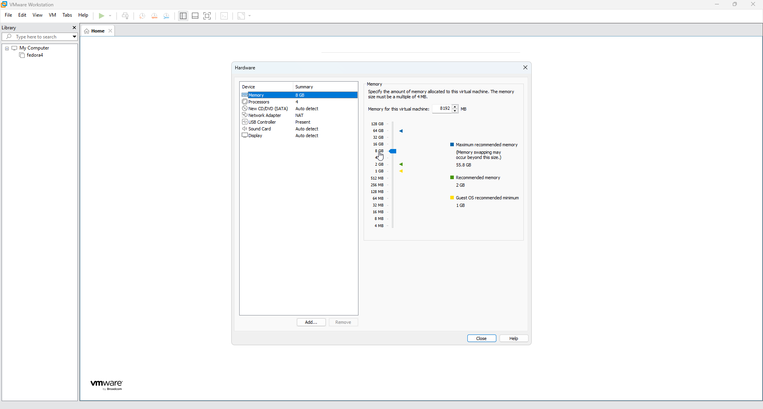
- Click on Processors and specify 2 processors with 2 cores per processor, making a total of 4 processor cores.
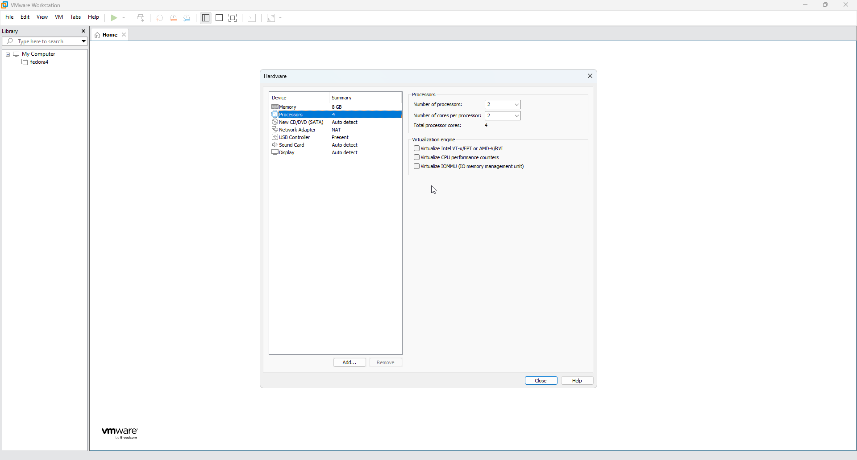
- Select New CD/DVD (SATA), choose "Use ISO image file", and browse to select your Debian 13 installation ISO (e.g., E:\isos\debian-13.4.0-amd64-netinst.iso).
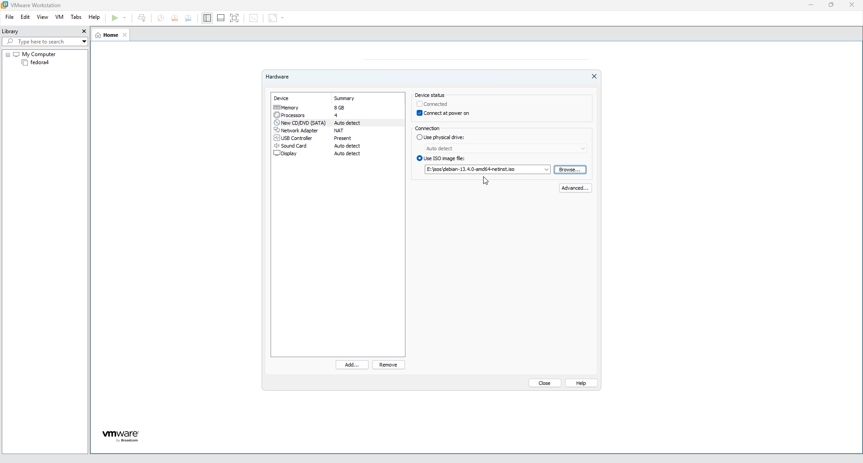
- Go to Network Adapter and select "Bridged: Connected directly to the physical network" to allow the VM to share your host's network connection.
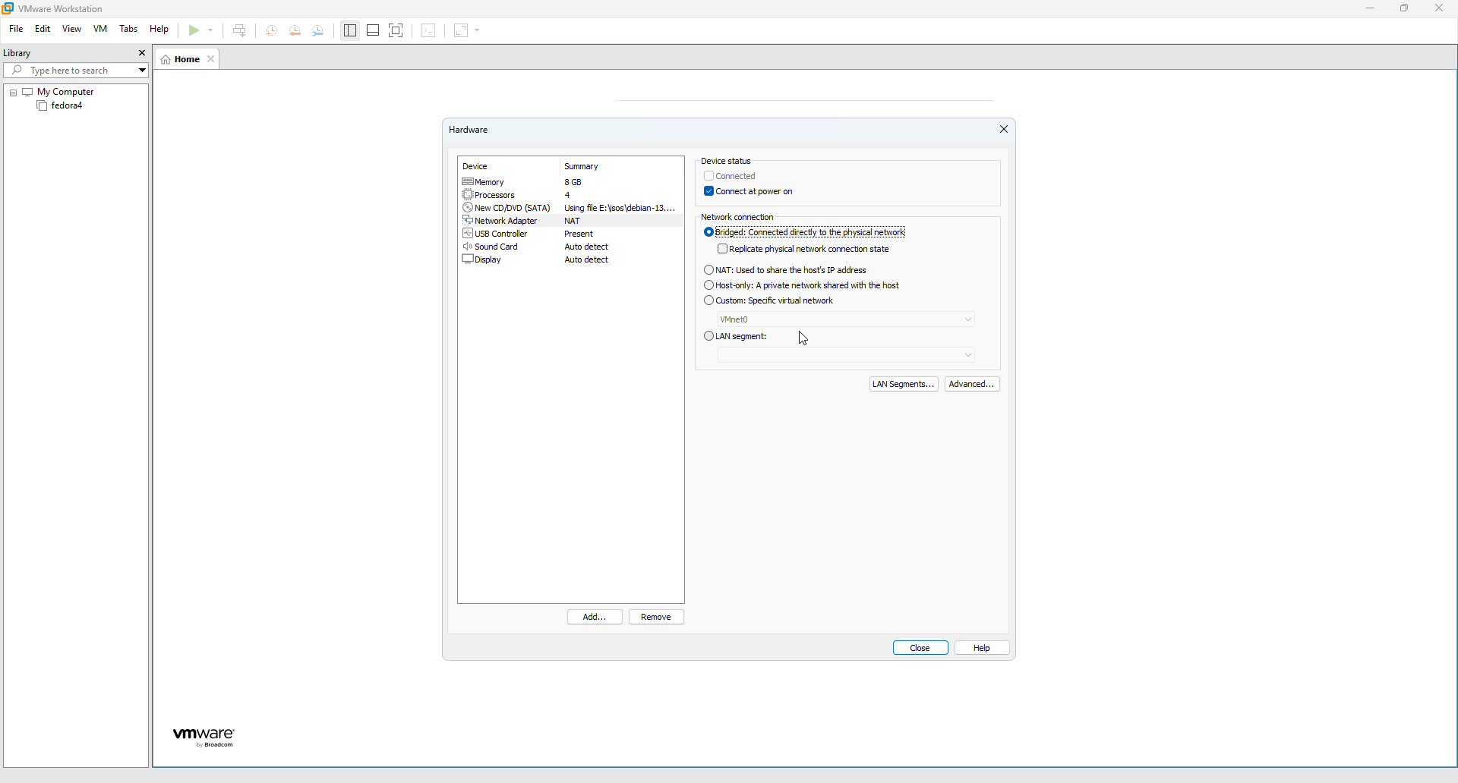
- Close the hardware customization window to finish creating the VM, then click "Power on this virtual machine" in the main VMware window.
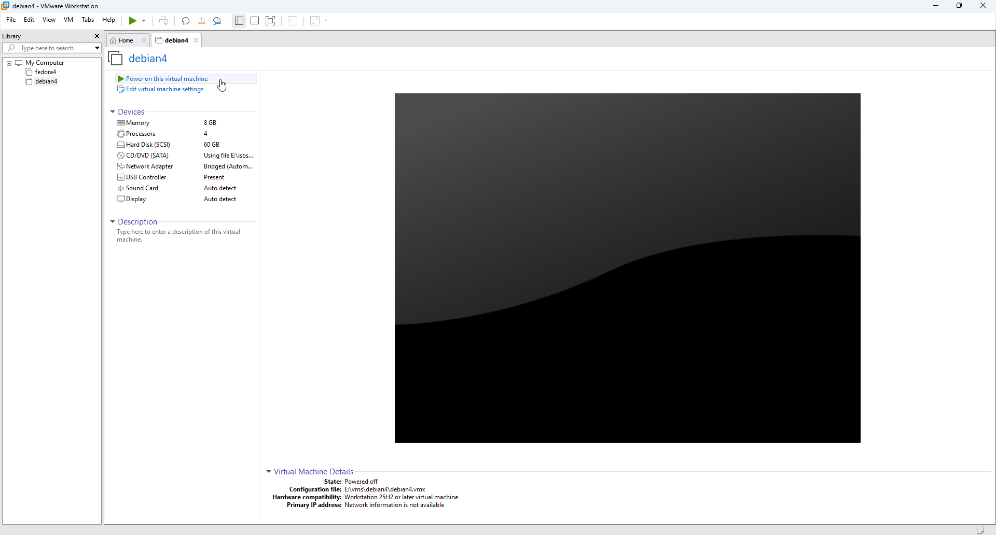
Phase 3: Installing Debian 13
- When the VM boots into the Debian 13 installer menu, select "Graphical install".
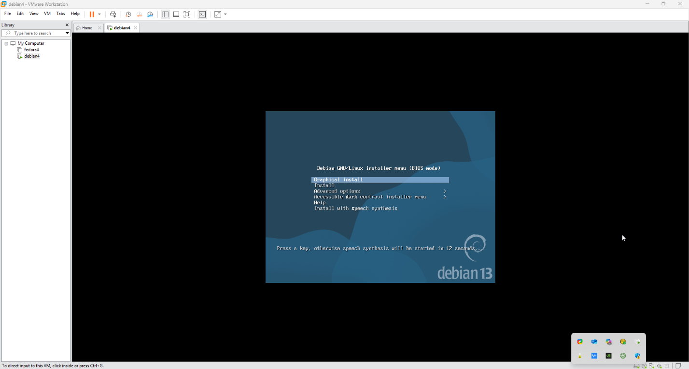
- Choose English as your installation language, select your location (e.g., Canada), and pick your keyboard layout (e.g., American English).
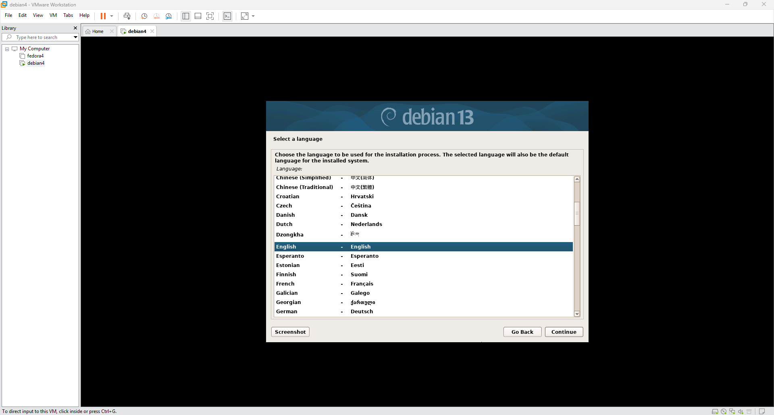
- Set your system's hostname and domain name(e.g., "debian4a" and “deb4a.com).
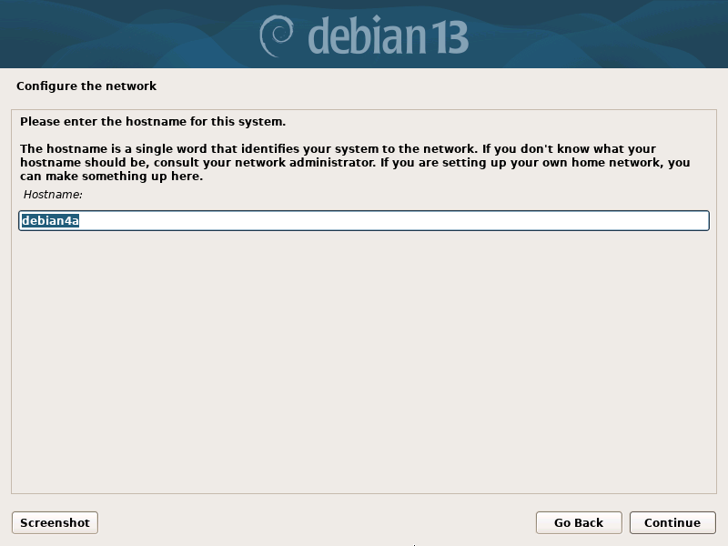
- Set up users and passwords: Create a strong Root password. Next, provide the full name for the new user (e.g., "student"), set the username to "student", and choose a strong password for this user account.
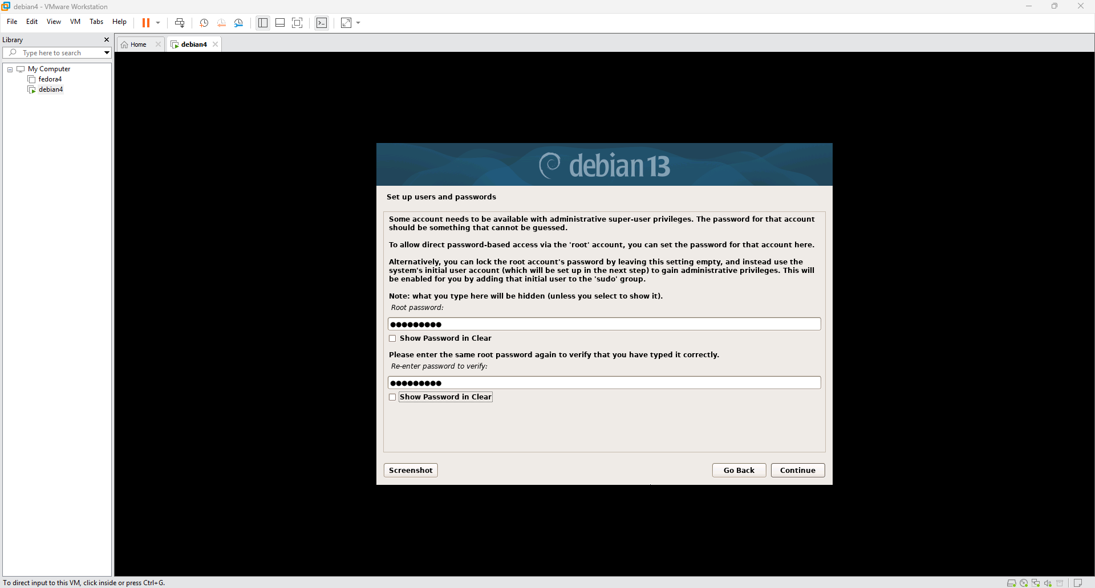
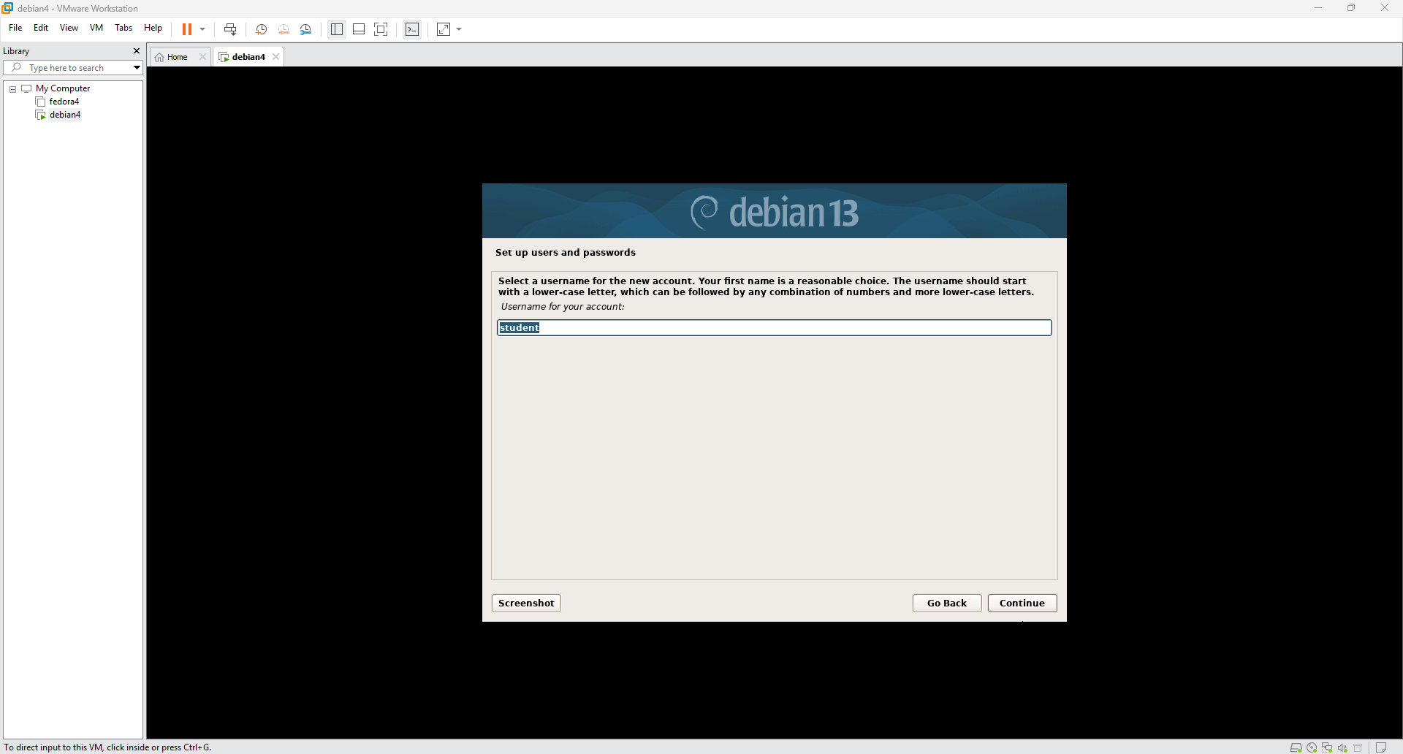
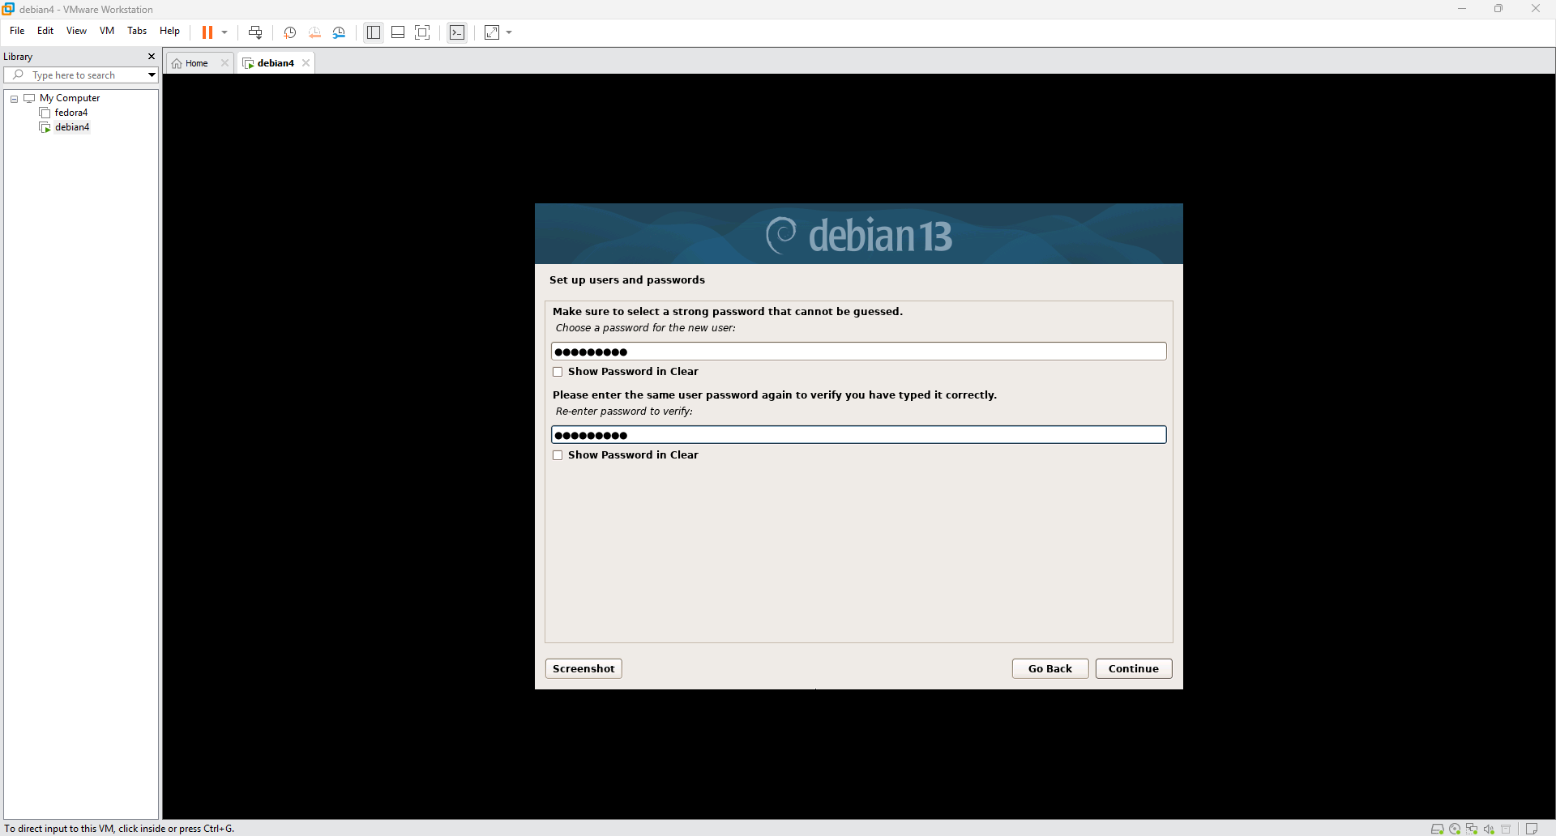
- Configure the clock by selecting your appropriate time zone (e.g., Eastern).
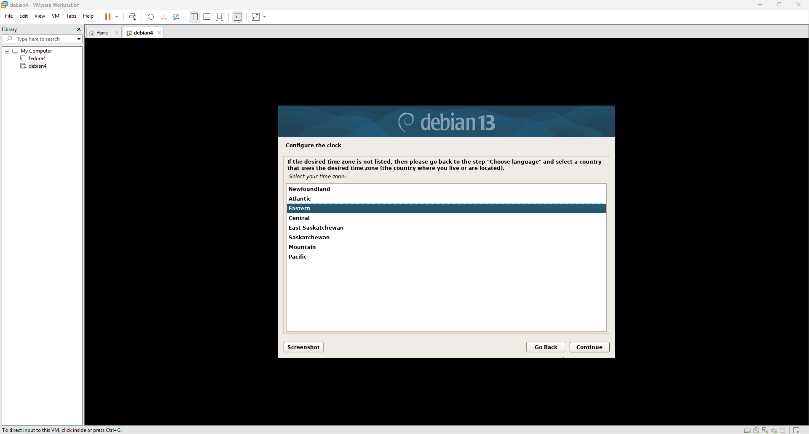
- Partition the disk: Select "Guided - use entire disk" and choose the 64.4 GB VMware virtual disk you created earlier. Pick the "All files in one partition (recommended for new users)" scheme. Select "Finish partitioning and write changes to disk" and confirm by checking "Yes".
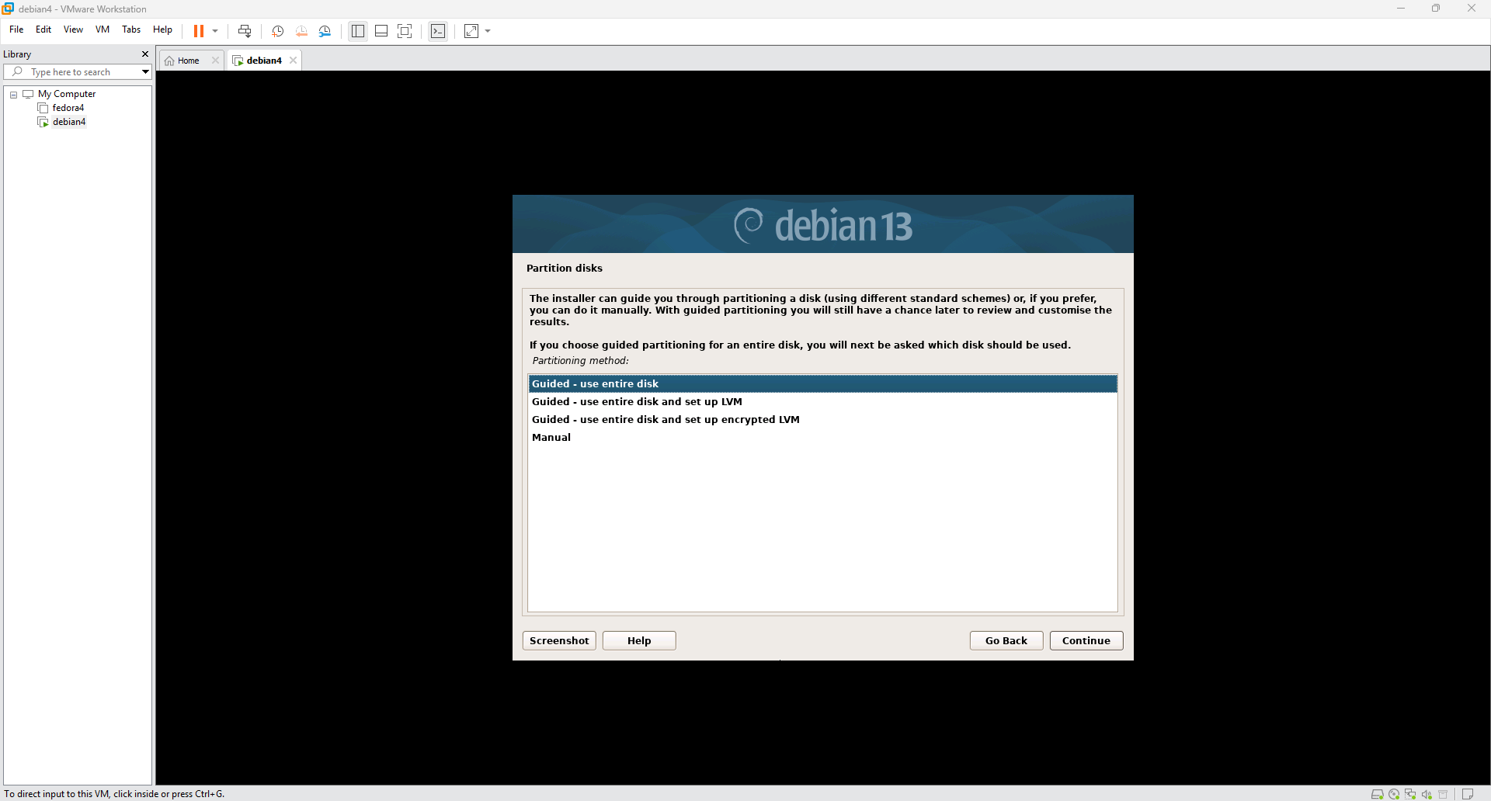
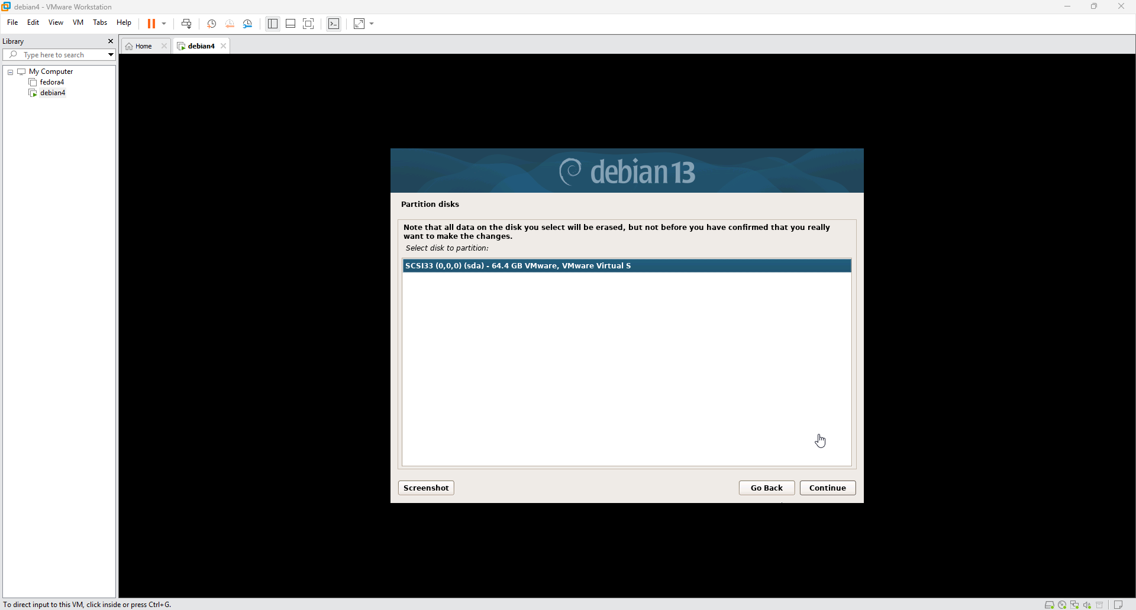
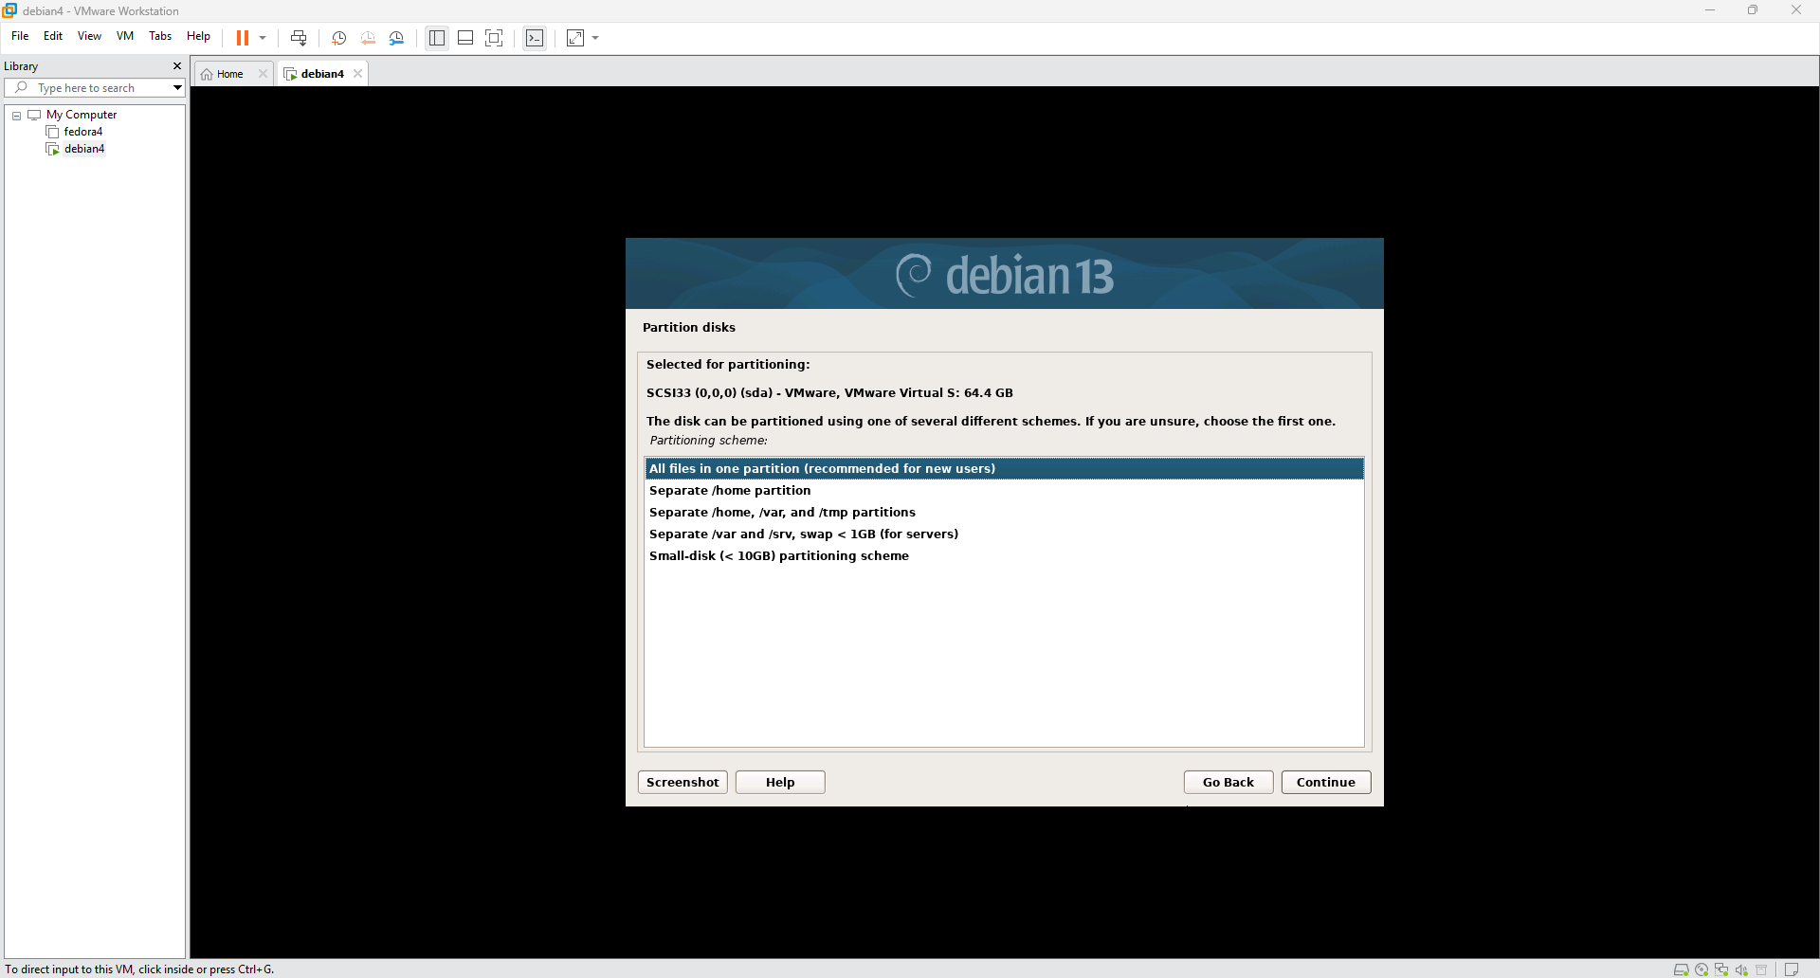
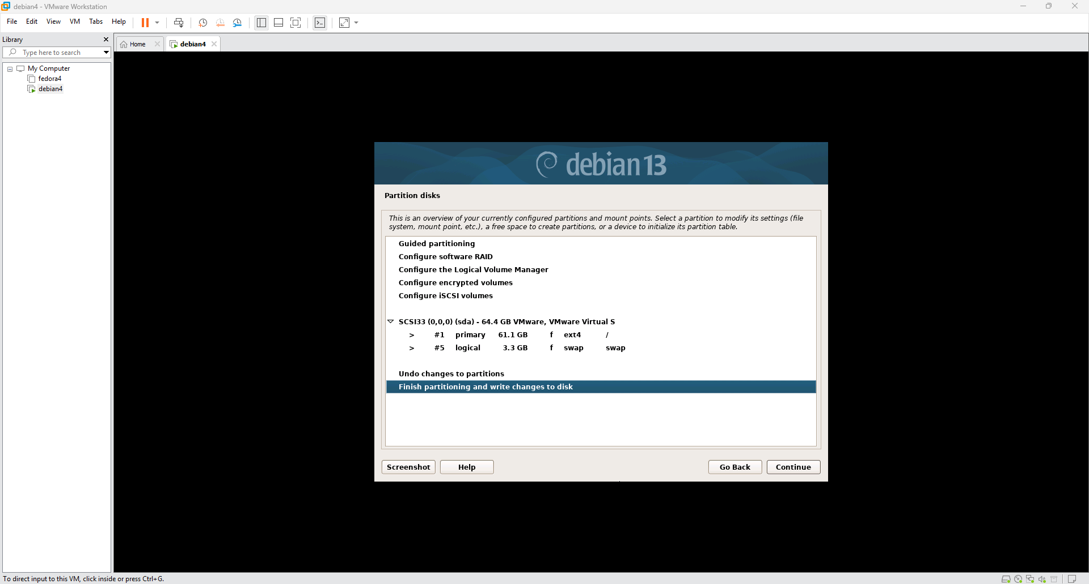
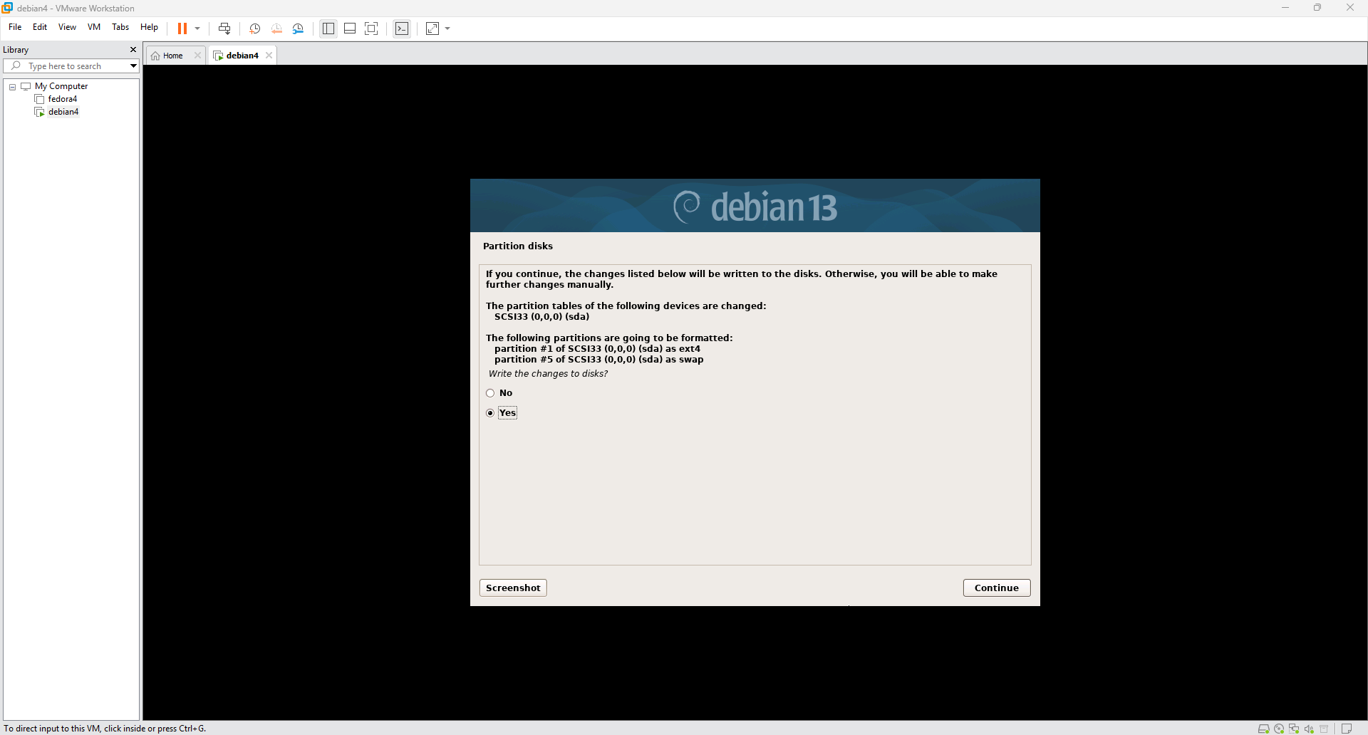
- Configure the package manager: When asked to scan extra installation media, select "No". Choose a Debian archive mirror close to your location (e.g., Canada), select the mirror address (e.g., deb.debian.org), and leave the HTTP proxy information blank if you don't use one.
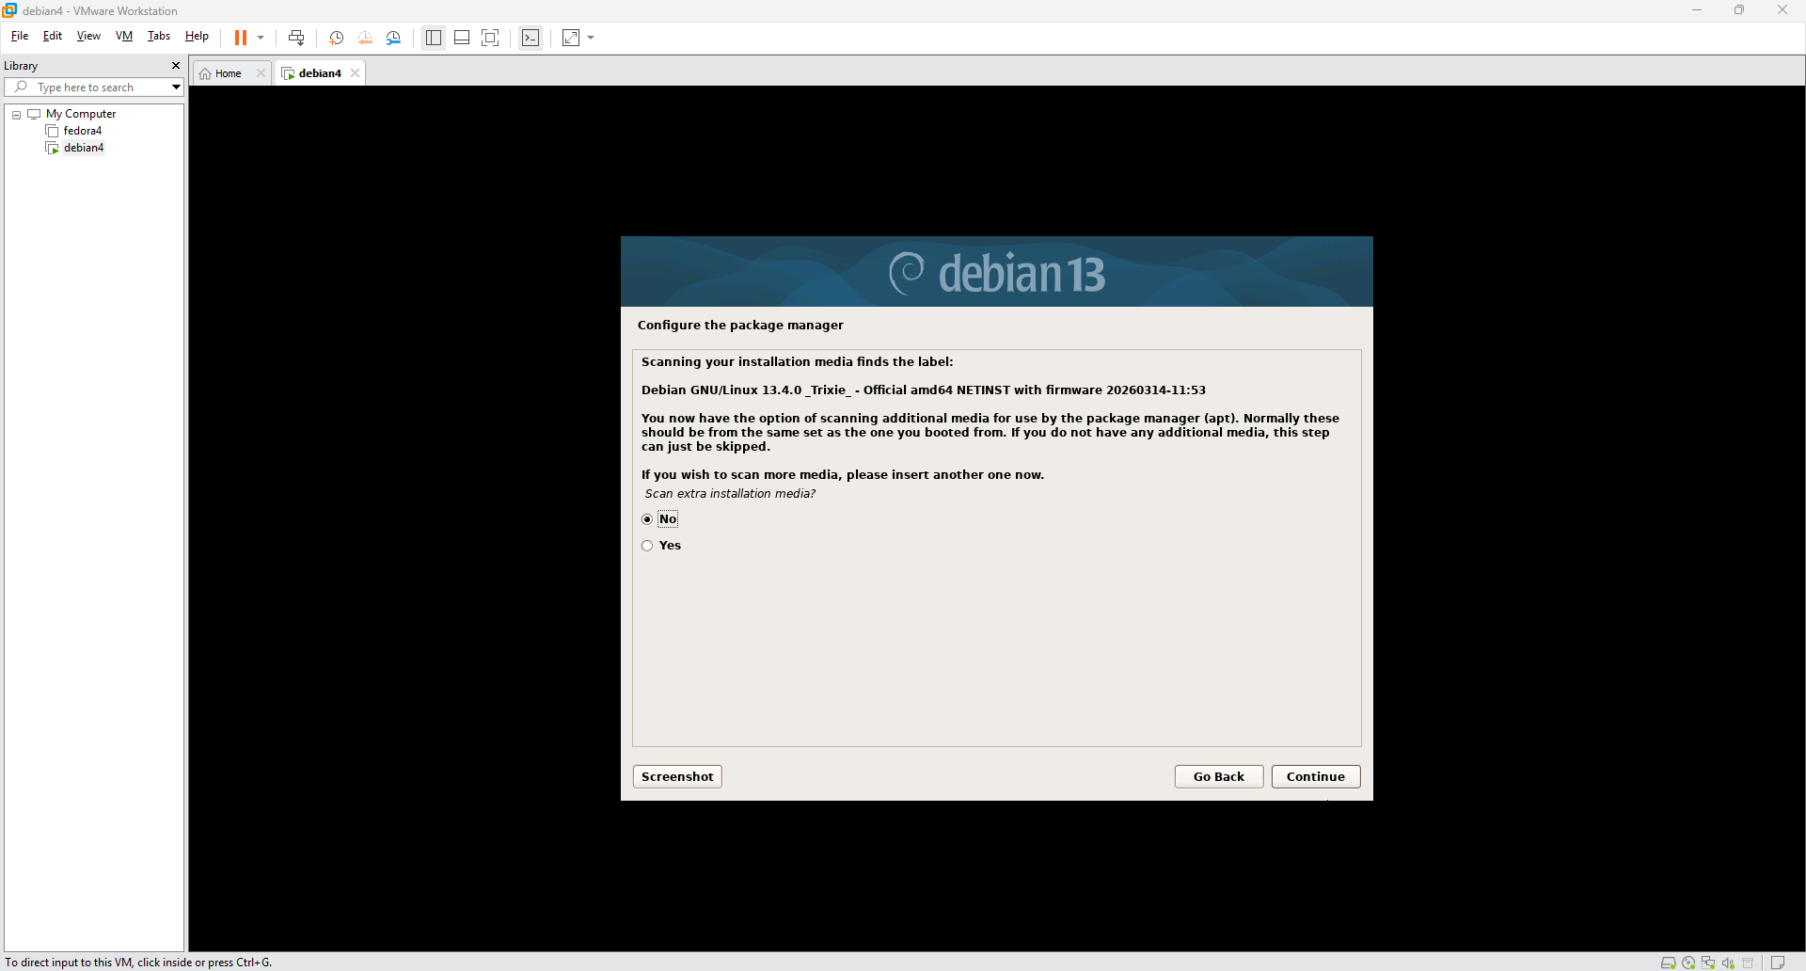
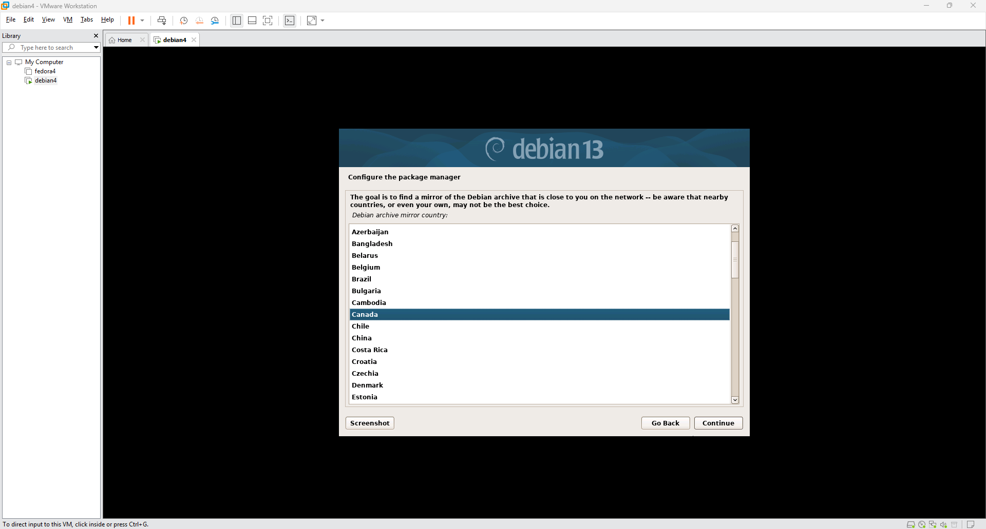
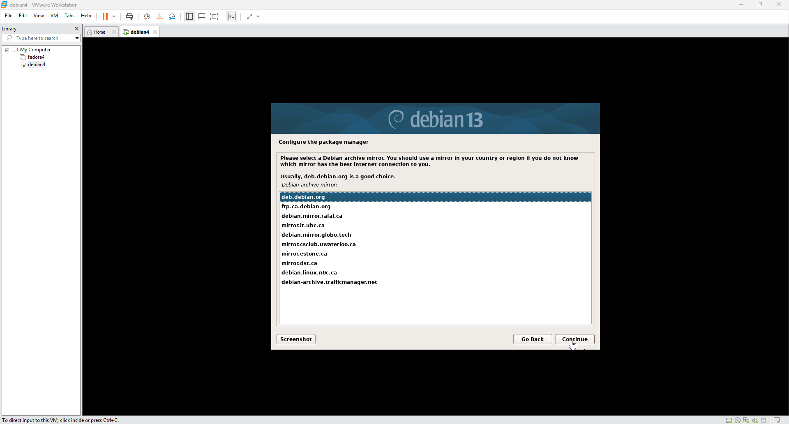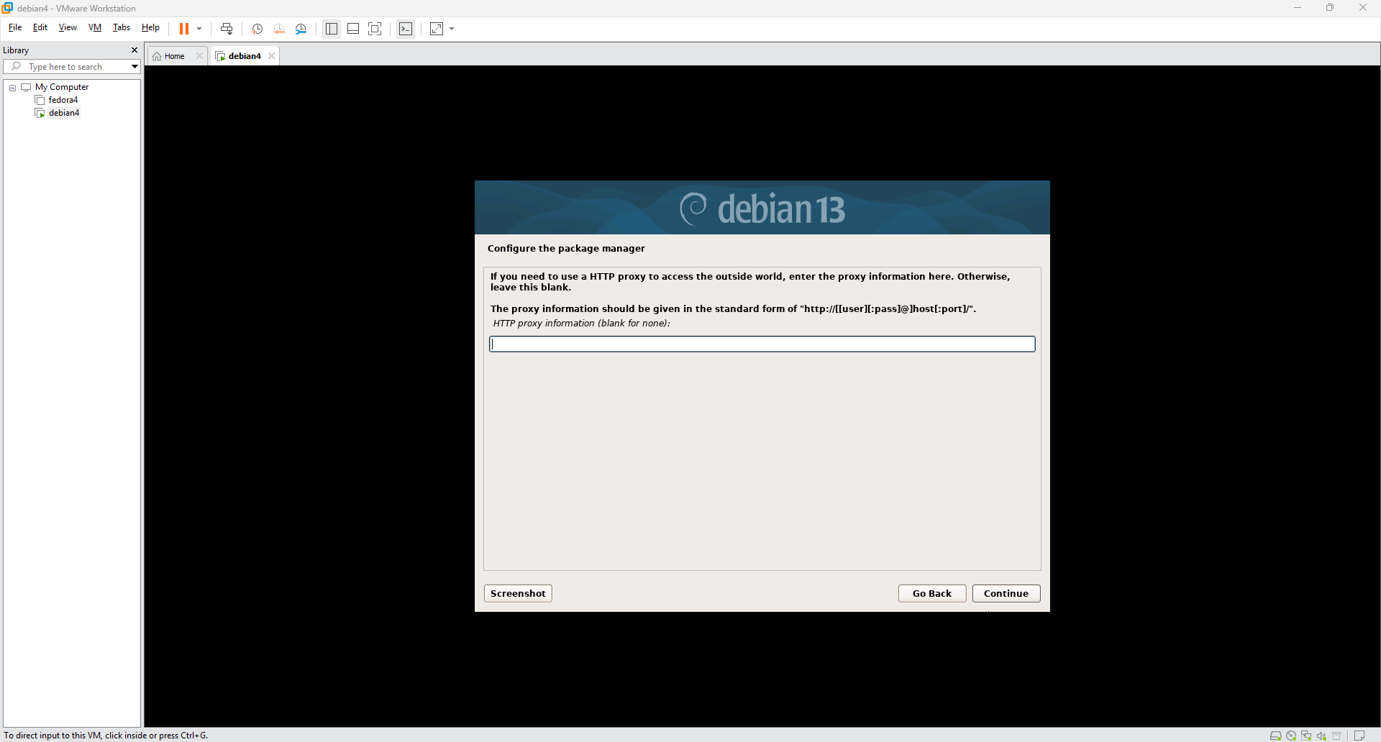
- You will be asked if you want to participate in the package usage survey; select "No".
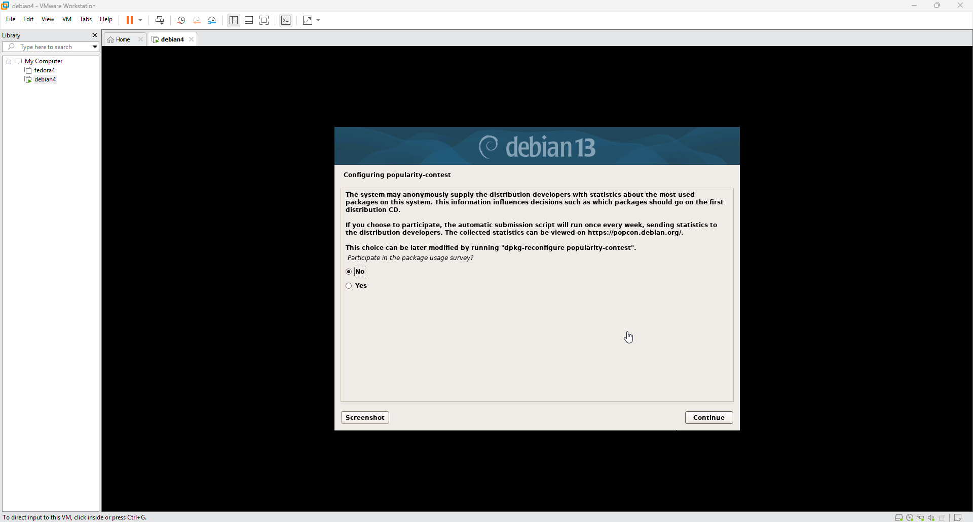
- Software selection: Choose the software to install. Check the boxes for "Debian desktop environment", "GNOME", and "standard system utilities".
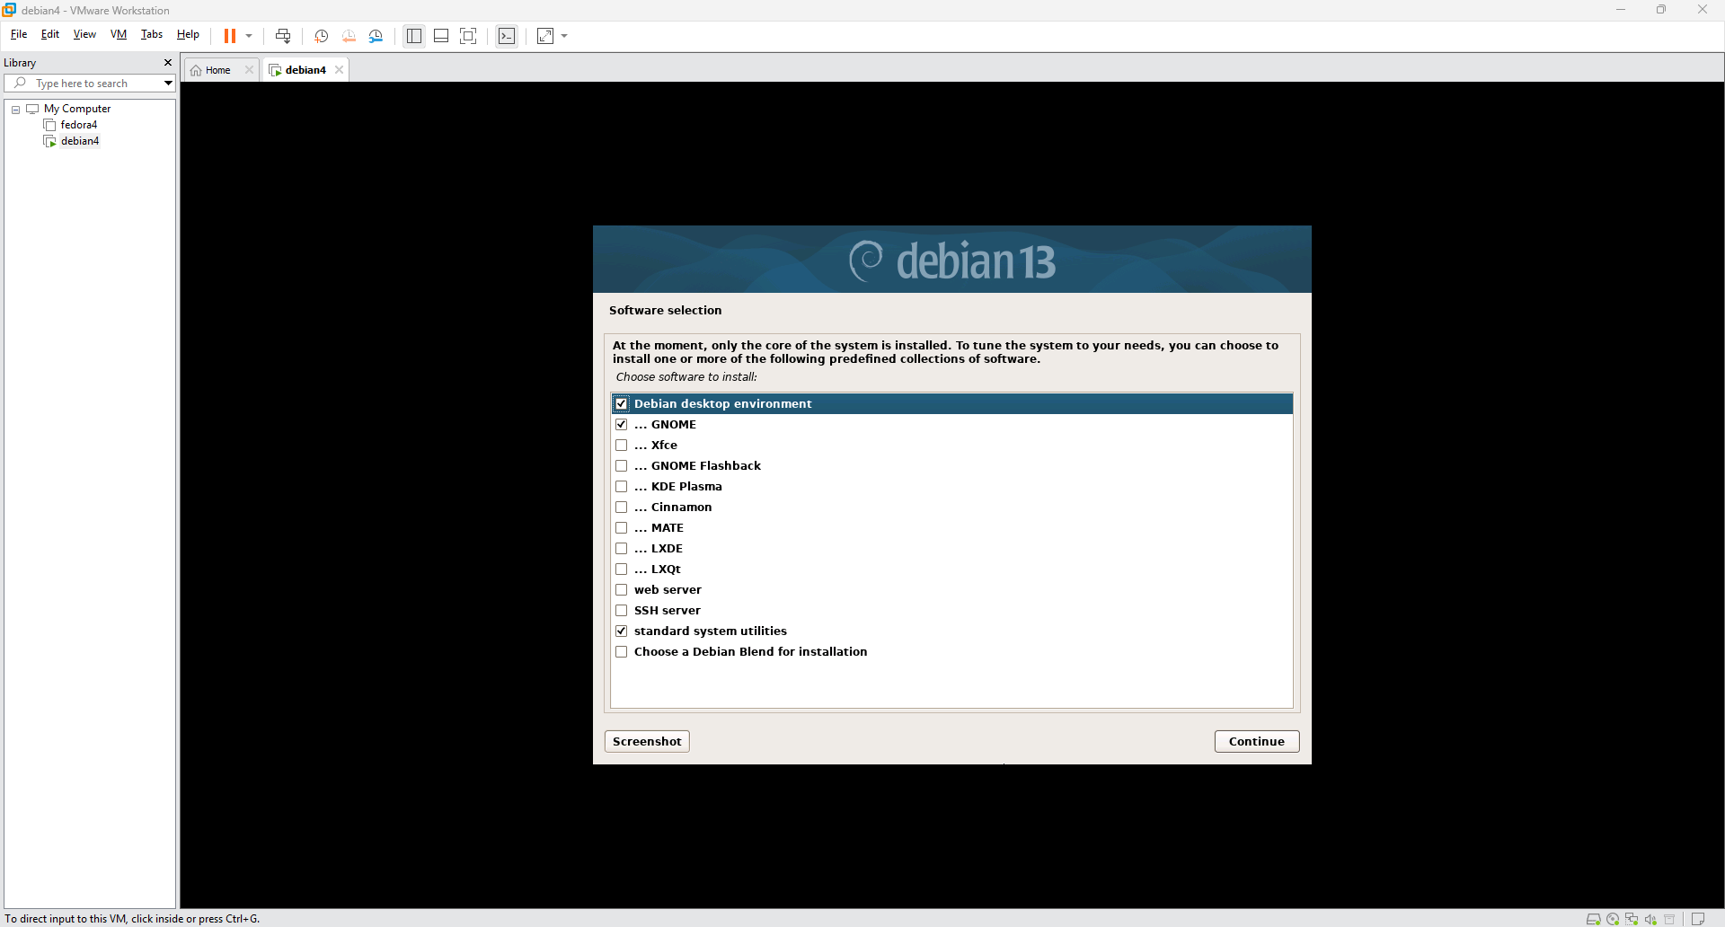
- When prompted, select "Yes" to install the GRUB boot loader to your primary drive. /dev/sda (VERY IMPORTANT)
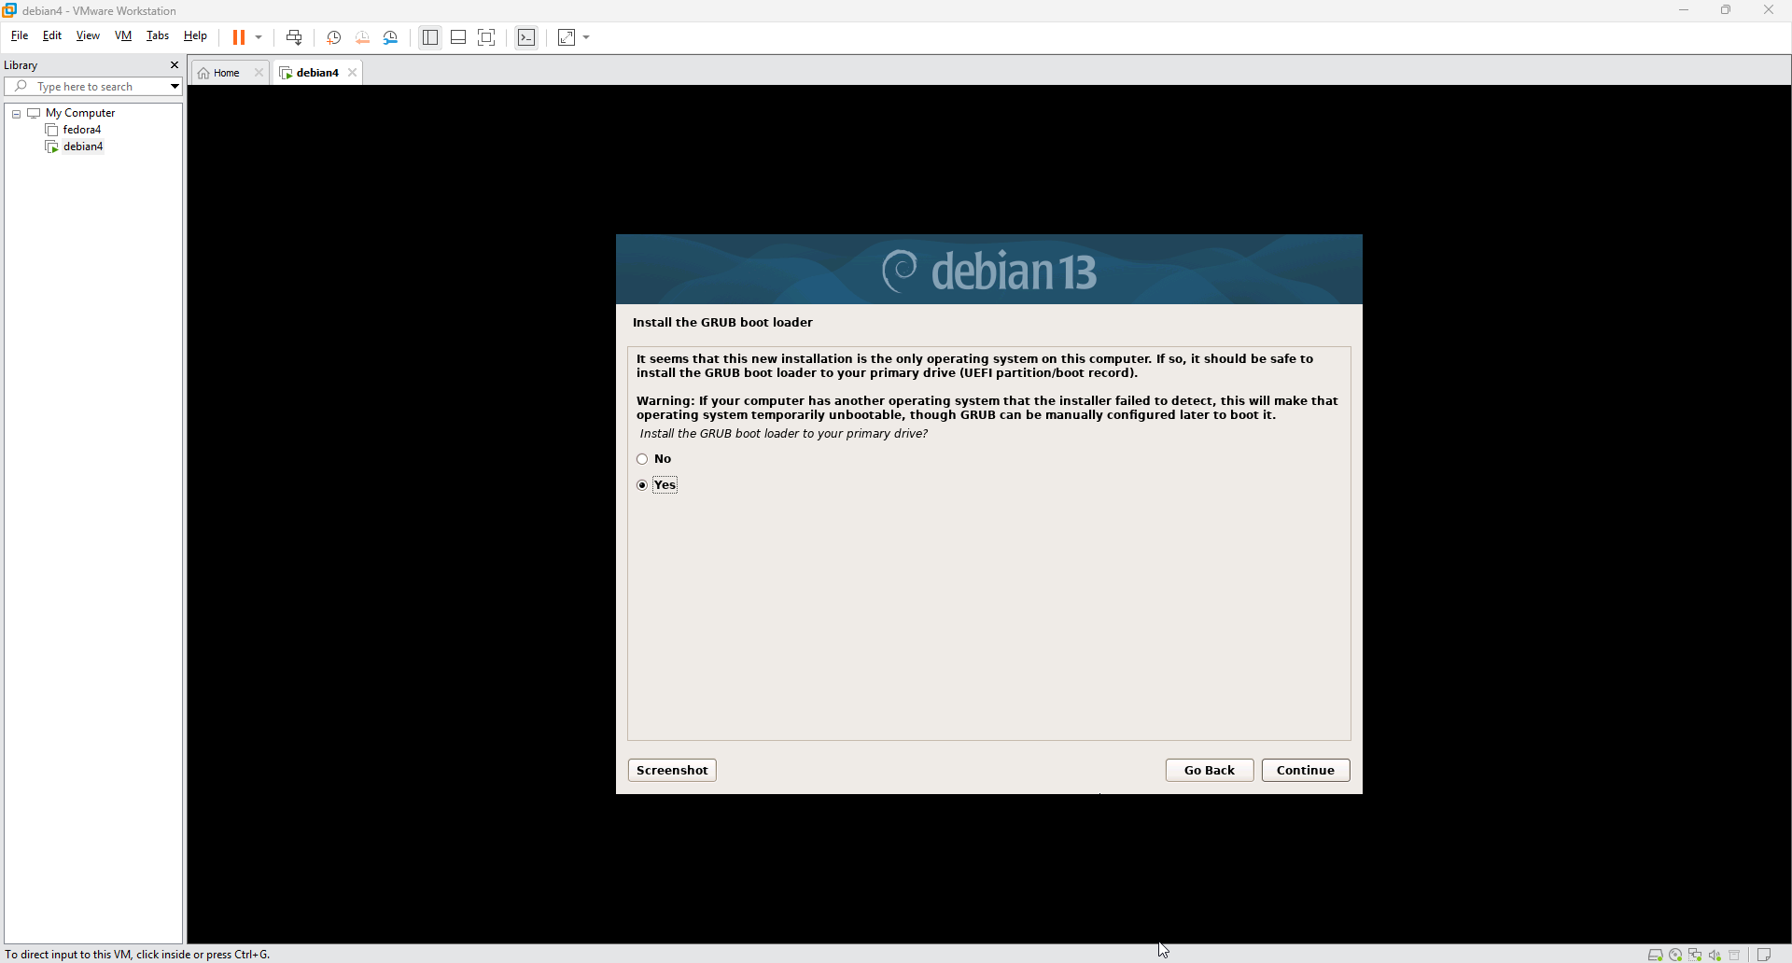
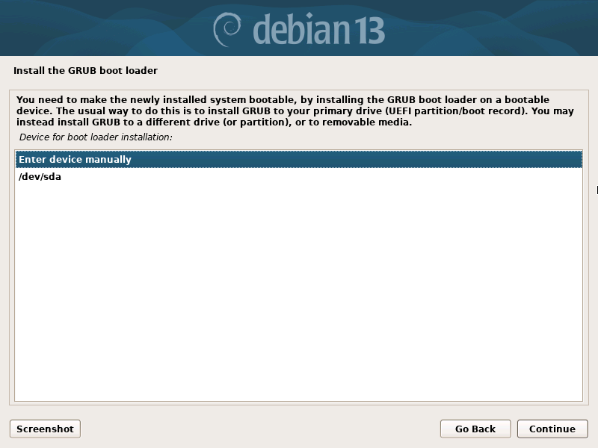
- Finally, you will reach the "Installation complete" screen. Choose Continue to reboot your new Debian system.
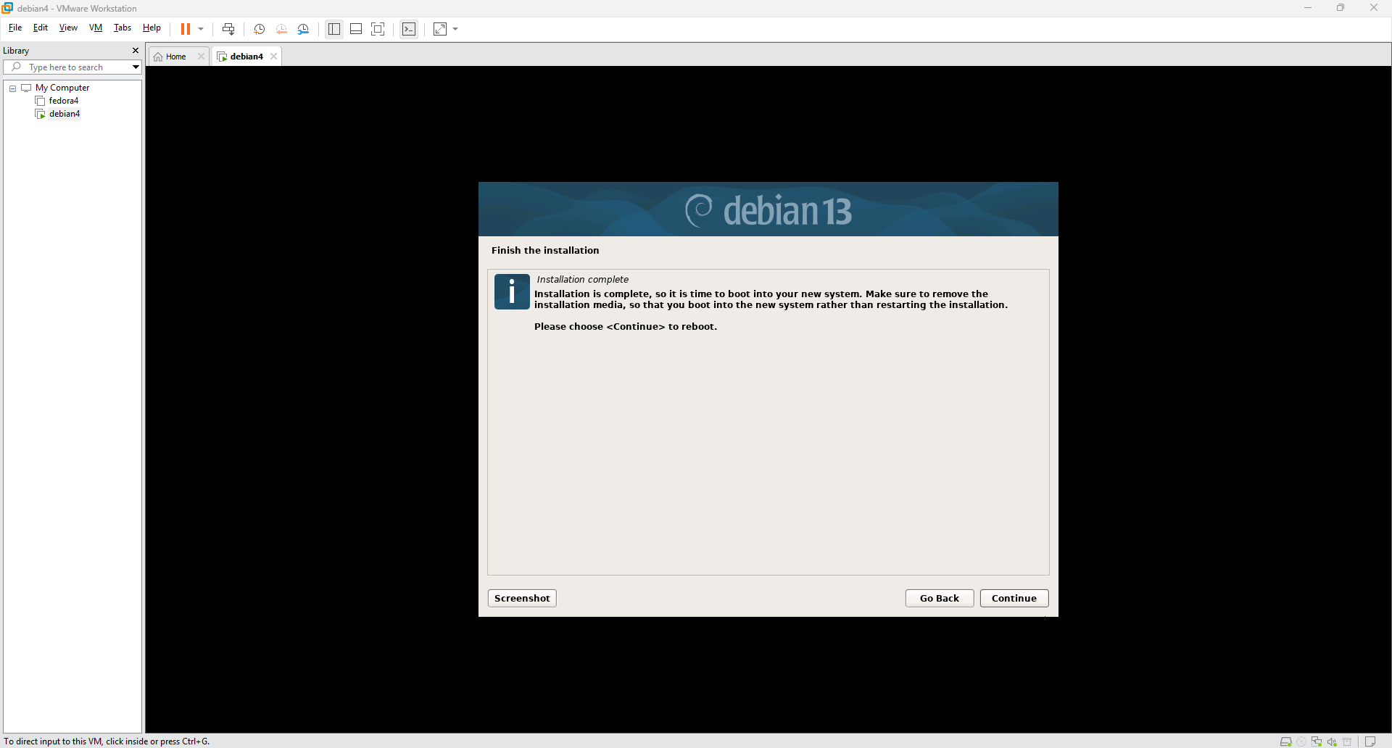
- Diffently from Fedora, Debian asks you to create a root password in the installation so you won’t need to create it in the command prompt when you boot it for the first time. Always run apt-get update and apt-get upgrade as soon as you start the CLI

Debian Configuration
Step 1: Assigning a Static IPv4 Address
Change the network interface settings from automatic to manual configuration. Enter a static IP address of 10.173.104.x, a netmask of 255.255.0.0, and a gateway of 10.173.0.1.
Make sure to insert into the hosts file the new ip using vim /etc/hosts
Click Apply in the top right corner to save these configurations.
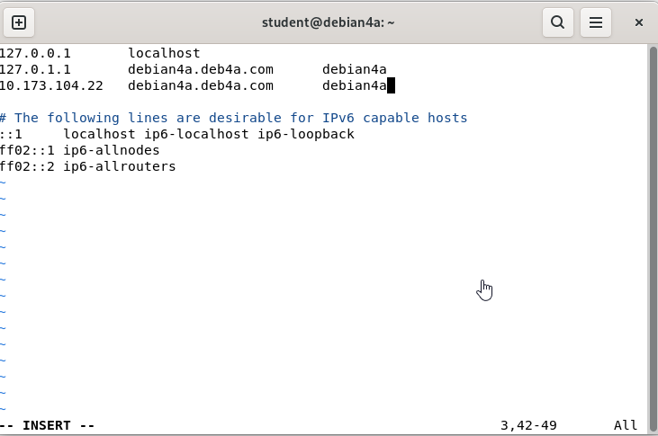
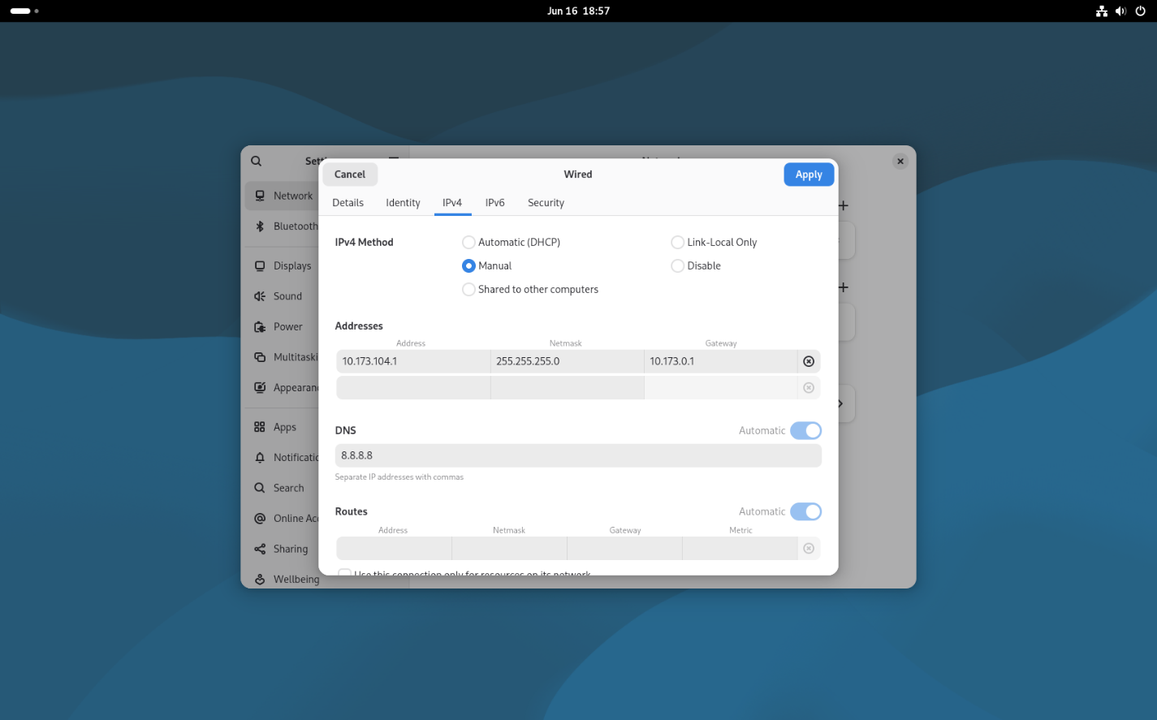

Step 2: Verifying Network IP and Connectivity
Open the terminal and run the ip add command to confirm that the ens33 interface displays your assigned static IP. Follow this with a ping 10.173.0.1 command to ensure the system successfully communicates with the gateway.
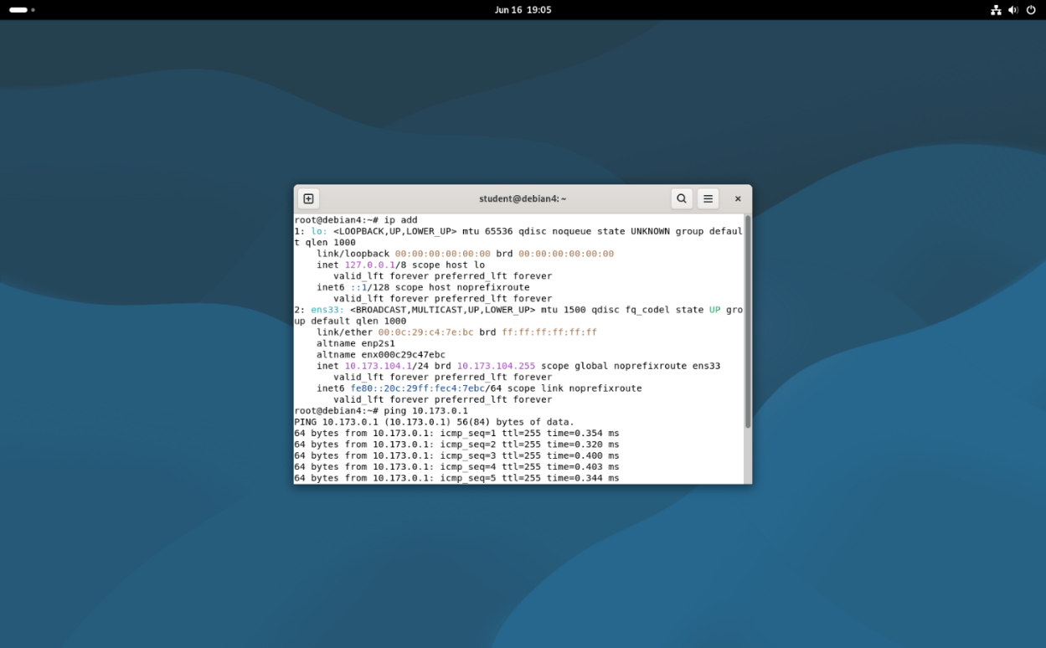
Step 3: Installing the Curl Package
Execute the command apt-get install curl
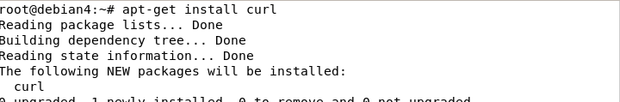
Step 4: Reviewing Webmin Repository Documentation
Open a web browser to locate the official Webmin installation documentation. Check if the command still the same: curl -o webmin-setup-repo.sh https://raw.githubusercontent.com/webmin/webmin/master/webmin-setup-repo.sh
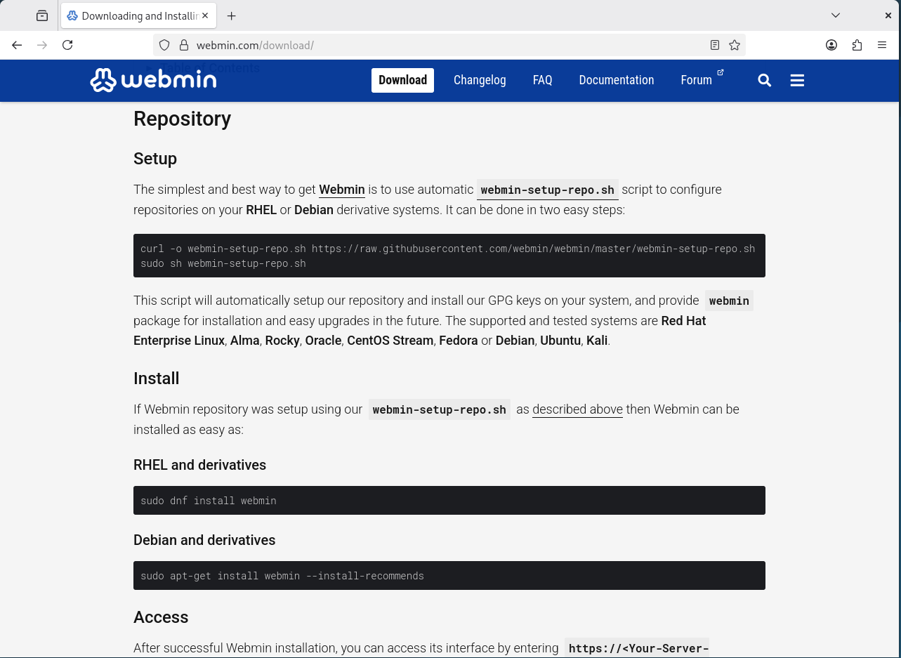
Step 5: Installing Webmin and Usermin via Terminal
Run the command apt-get install --install-recommends webmin usermin to fetch both system management panels simultaneously
Step 6: Installing BIND9 DNS Server
Install the local Domain Name System service by entering apt-get install bind9. When prompted by the package manager to confirm the disk space usage, type Y and press enter to proceed with the installation.
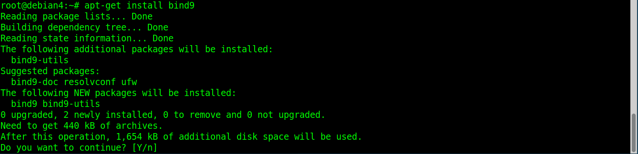

Step 7: Bypassing the Webmin Security Warning
Access the Webmin panel via your browser at https://10.173.104.2:10000. When confronted with the self-signed certificate warning, click Advanced... and choose Accept the Risk and Continue to safely load the login interface.
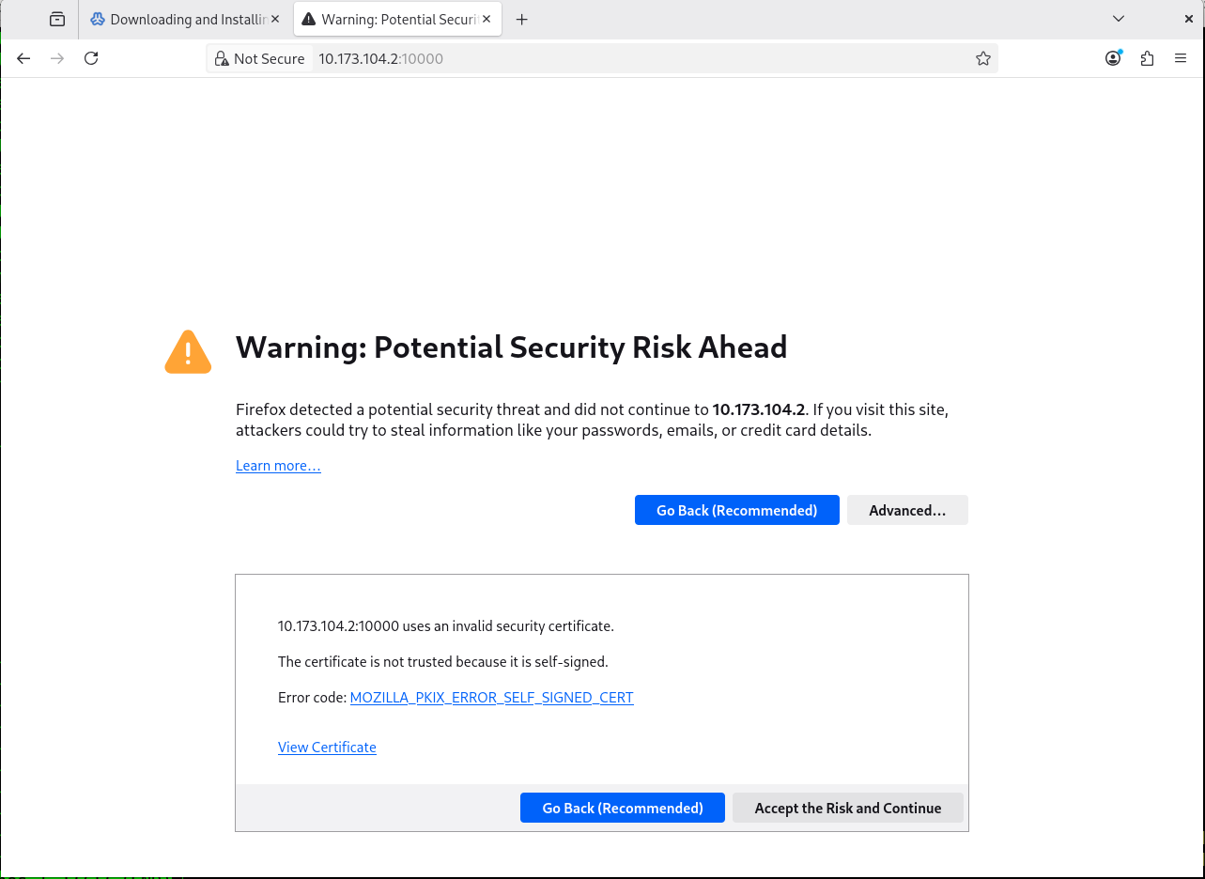

Step 8: Creating a DNS Master Zone
Navigate to the BIND DNS Server module inside Webmin and create a new Master Zone. Enter deb4.com as the domain name and specify debian4.deb4.com as the master server and email address root.deb4a.com (deb11 is a mistake) before clicking Create.
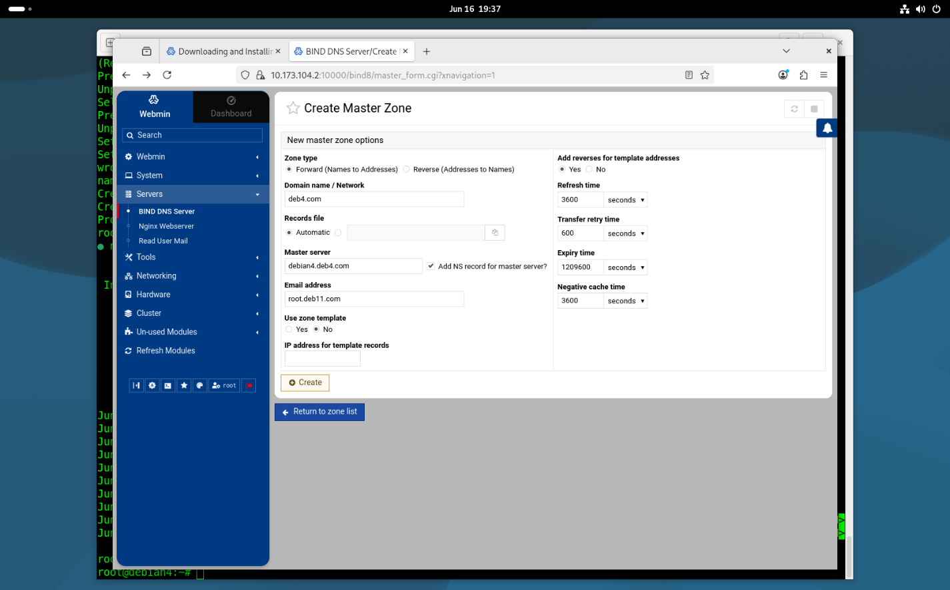
Step 9: Managing IPv4 Address Records (A Records)
Create 3 ip addresses debian4.deb4.com and www.deb4.com and blank to accurately point to your server IP of 10.173.104.2. Use this panel to add new entries or delete outdated records.
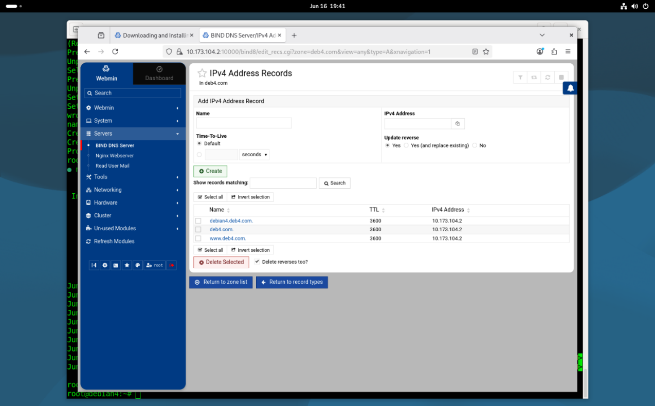
Step 10: Adding a Name Alias Record (CNAME)
Create an alias to map an alternative name to your primary domain. Type ftp in the name field, enter the absolute domain name debian4.deb4.com. in the real name field, and click Create to finish the setup.
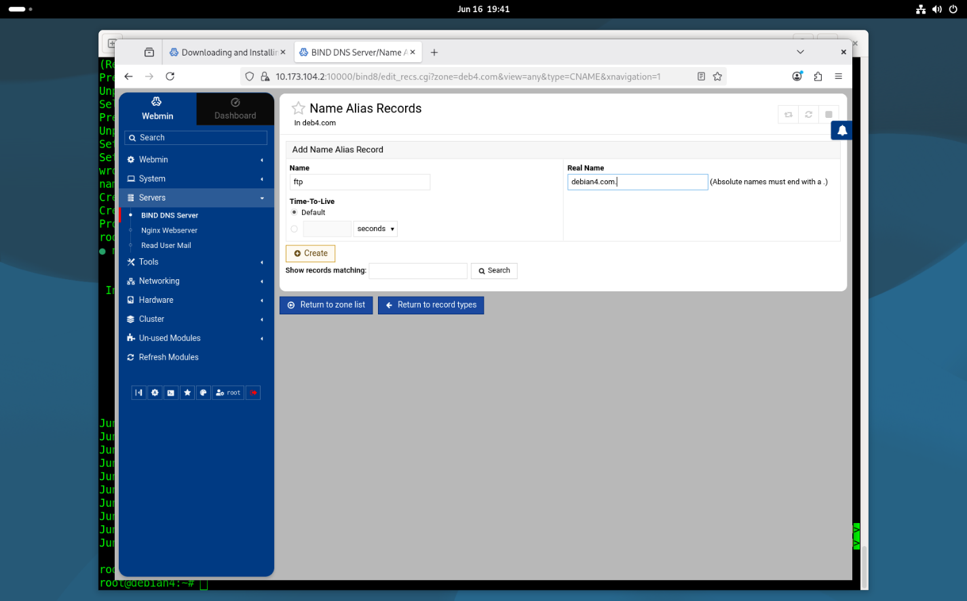

Step 11: Configuring Mail Server MX Records
In the BIND DNS Server module within Webmin, create a new Mail Server (MX) Record. Set the name field to deb4.com., enter deb4.com. in the Mail Server field, and set the Priority to 5. Click Create to establish the primary route for incoming email traffic.
Stop and start the service after every change. Change the DNS IP in the NIC to your IP 10.173.104.2
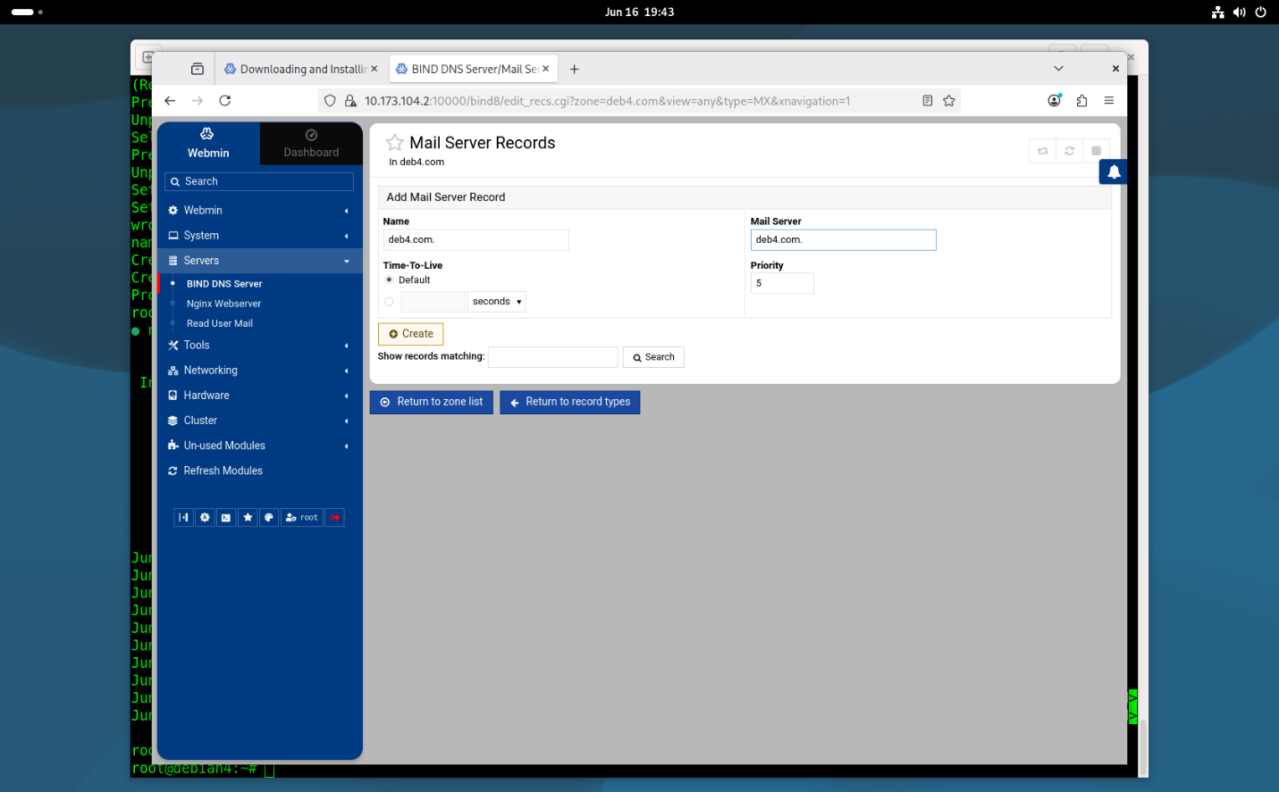
Step 12: Installing the Postfix Mail Transfer Agent
Return to the terminal and execute the command apt-get install postfix to install the mail transfer service.
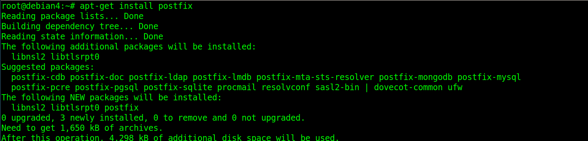
Step 13: Choosing the Postfix Configuration Environment
When the blue package configuration screen appears, select Internet Site from the menu using your arrow keys. This option configures Postfix to send and receive mail directly over the network using standard SMTP protocols. Press Enter to confirm your choice.
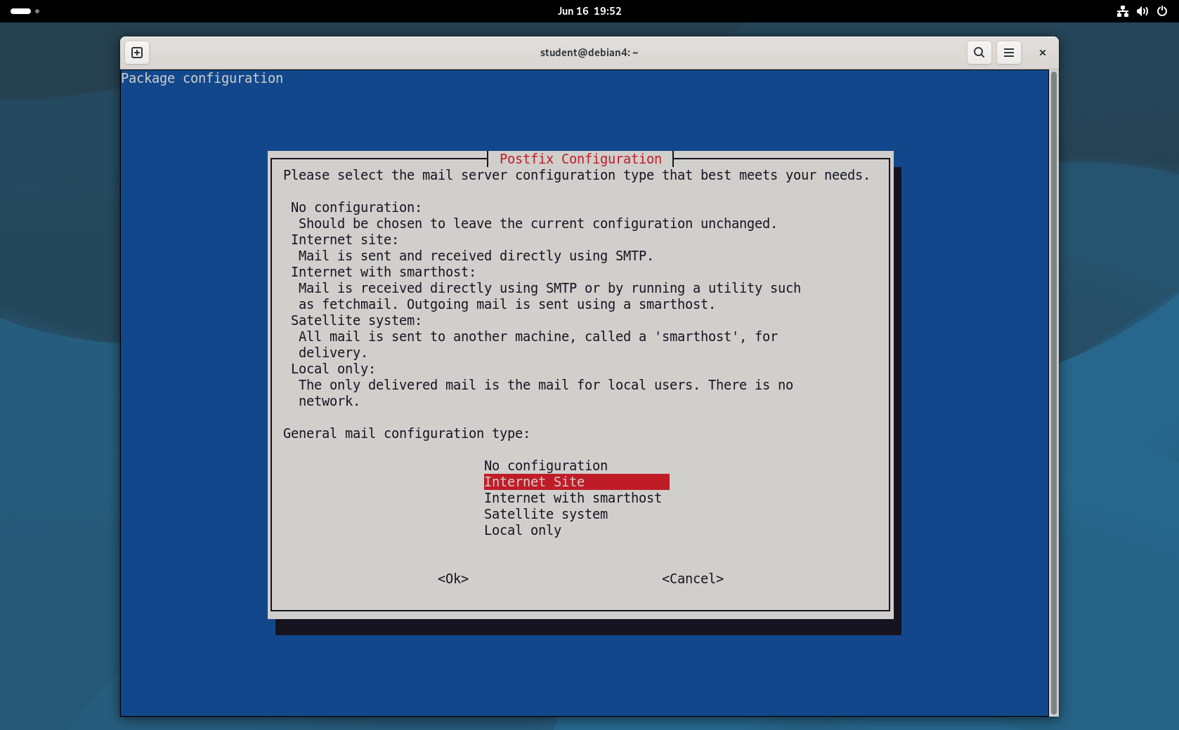
Step 14: Setting the System Mail Name
In the next configuration dialogue box, type out your single, fully qualified domain name (FQDN). Enter debian4.deb4.com in the text field to properly qualify all outgoing user email addresses that lack a specified domain name, then select .
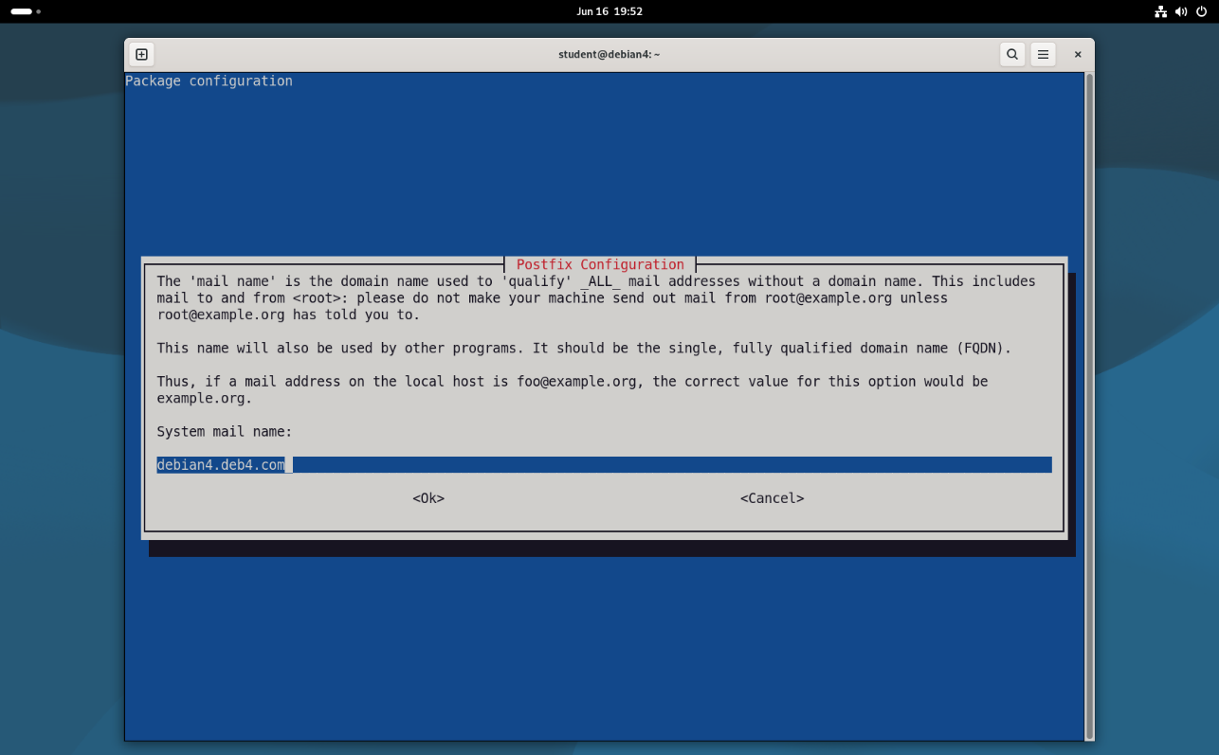
Step 15: Accessing the Postfix Configuration Directory
Navigate to the mail settings directory by running cd /etc/postfix in your terminal. Execute vim main.cf to edit the core global parameters of your mail transfer agent.
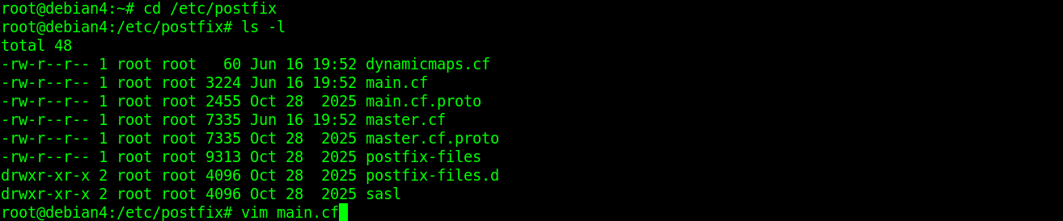
Step 16: Adjusting Local Mail Destinations
Locate the mydestination directive line inside your main.cf file using the text editor. Ensure that all variations of your domain and local loopback aliases—such as debian4.deb4.com, localhost.deb4.com, and deb4.com—are added to the list so the server accepts incoming traffic for these endpoints. Also add your network ip to mydestination = 10.173.0.0/16
Step 17: Installing the Alpine Mail Client
Execute the command apt-get install alpine in your command line. This installs a lightweight, terminal-based mail user client that allows administrators to check, read, and test local mail routing directly from the terminal console.
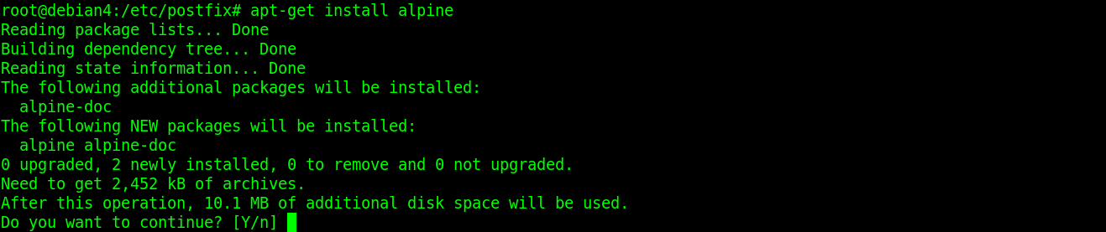
Step 18: Installing Dovecot IMAP and POP3 Services
Create user set a psswd and open alpine to create mail folders. Run the command apt-get install dovecot-core dovecot-pop3d dovecot-imapd dovecot-lmtpd to set up your secure mail retrieval protocols.
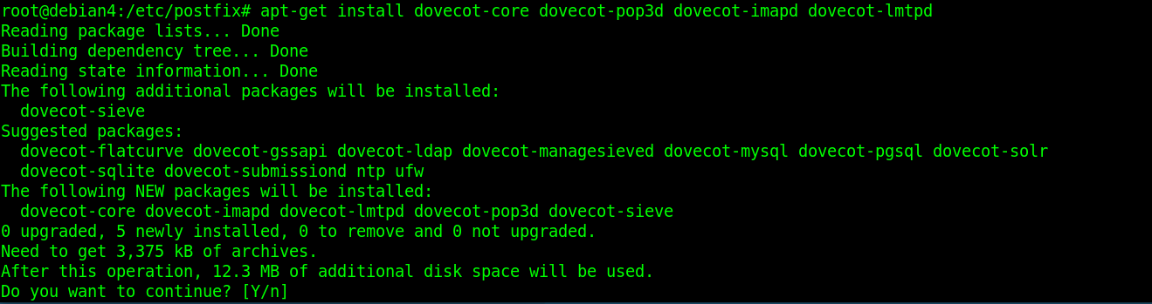
Step 19: Editing Dovecot Authentication Settings
Change your current working directory to the configurations folder by using cd conf.d under /etc/dovecot/. Run ls to view your available control scripts, and execute vim 10-auth.conf to open and configure user login parameters.
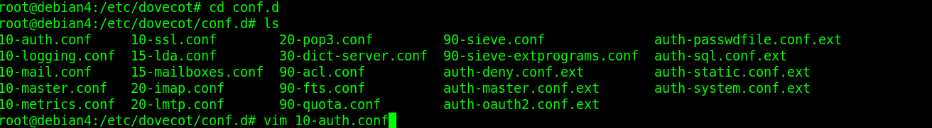
Step 20: Disallowing Cleartext Authentication
Inside your text editor for the Dovecot configuration files, find the authentication parameters line. Ensure that the statement auth_allow_cleartext = no is active and uncommented. This configuration stops users from sending unencrypted credentials over the network when SSL/TLS protections are absent.
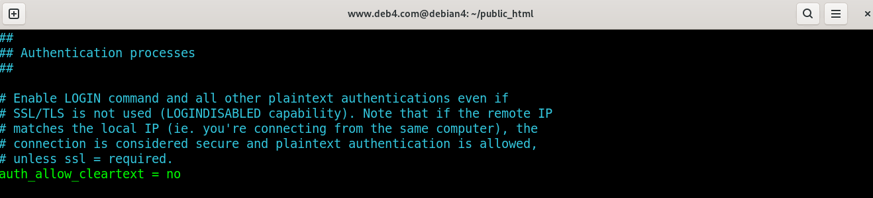
Step 21: Initializing Manual Mail Client Configuration
Open Outlook and select the button for Manual setup or additional server types to bypass automated discovery, then click Next to proceed.
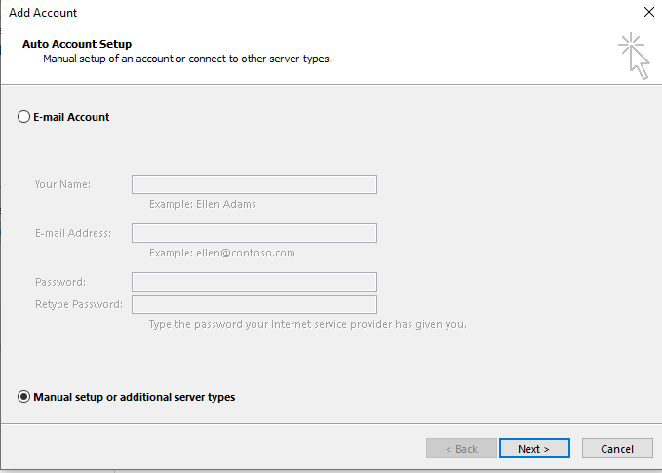
Step 22: Entering Mail Account and Server Information
Populate the user, server, and logon parameter blocks with your specific domain details. Set the account type to POP3 and point both the incoming and outgoing mail fields directly to your server IP of 10.173.104.2. Make sure Require SPA is selected. Click More Settings...
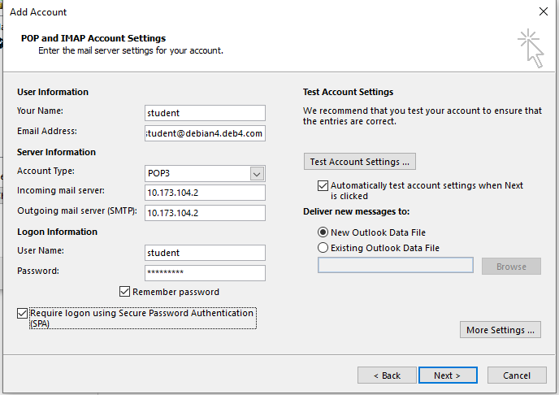
Step 23: Adjusting Advanced Server Port Settings
Navigate to the Advanced tab check the box indicating that the server requires an encrypted connection (SSL). Make sure incoming server uses port 995 and outgoing 25.
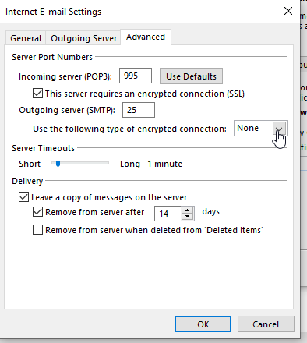
Step 24: Allowing DNS Zone Transfers to the Slave Server
In your BIND DNS Server navigate to the Zone Options for deb4.com. Under the Allow transfers from... field, enter the IP address of your class DNS server (10.173.112.250) and Allow queries from… any. Click Save to authorize the slave server to pull copy records from this master zone.
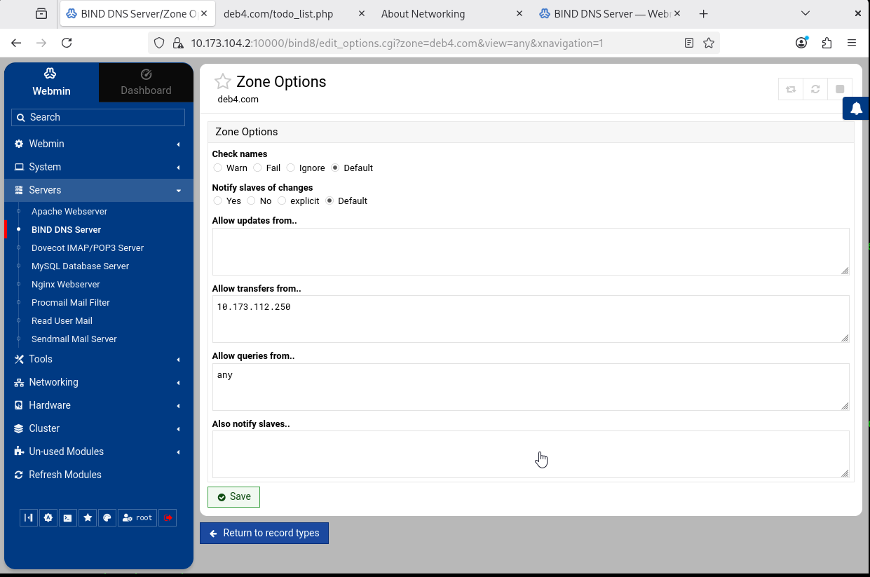
Step 25: Creating the Slave DNS Zone
Switch to the Webmin panel of your class server (10.173.112.250) and choose to create a new Slave Zone. Set the Zone type to Forward, enter deb4.com into the domain field, and input the Master server IP address of 10.173.104.2. Start and stop server
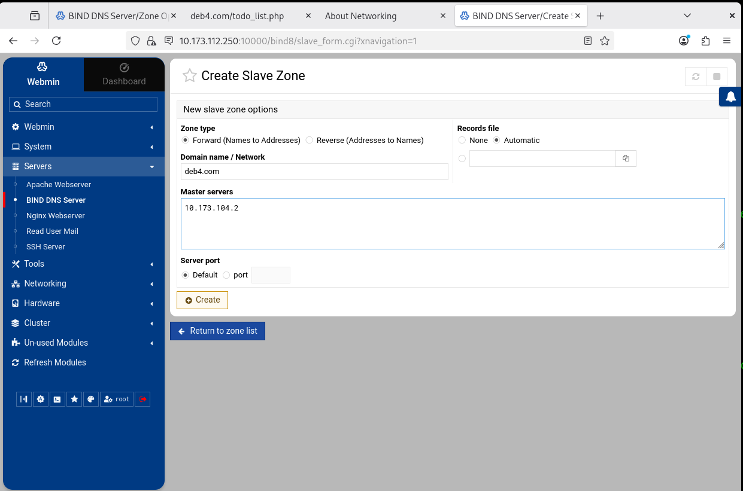
Step 26: Installing the Apache2 Web Server
Run the command apt-get install apache2 to install Apache.
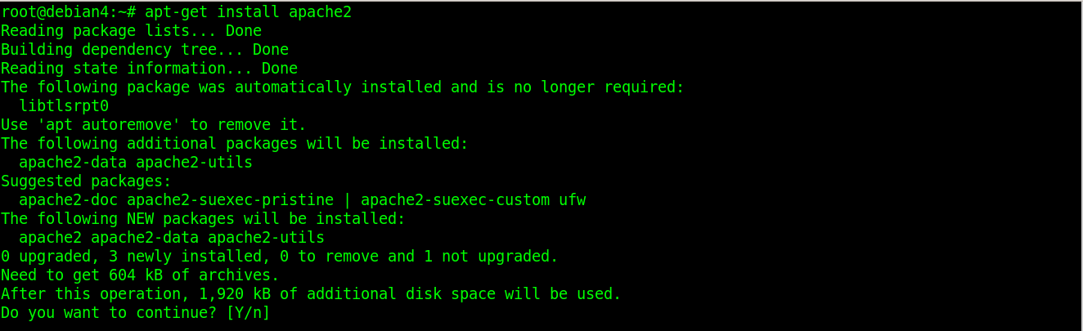

Step 27: Staging a New Virtual Host File
Navigate to the active configuration pool folder by running cd /etc/apache2/sites-available/. Execute cp 000-default.conf 001-deb4.com.conf to duplicate the standard fallback configuration file into a unique template tailored for your new web domain.
Step 28: Configuring Virtual Host Domain Directives
Open your newly cloned configuration script using a text editor vim /etc/apache2/sites-available/000-deb4.com.conf. Update the section with:
ServerName www.deb4.com
ServerAlias deb4.com
ServerAdmin webmaster@localhost
DocumentRoot /home/www.deb4.com/public_html (for production environment it is recommended use /var/www/html for better security)

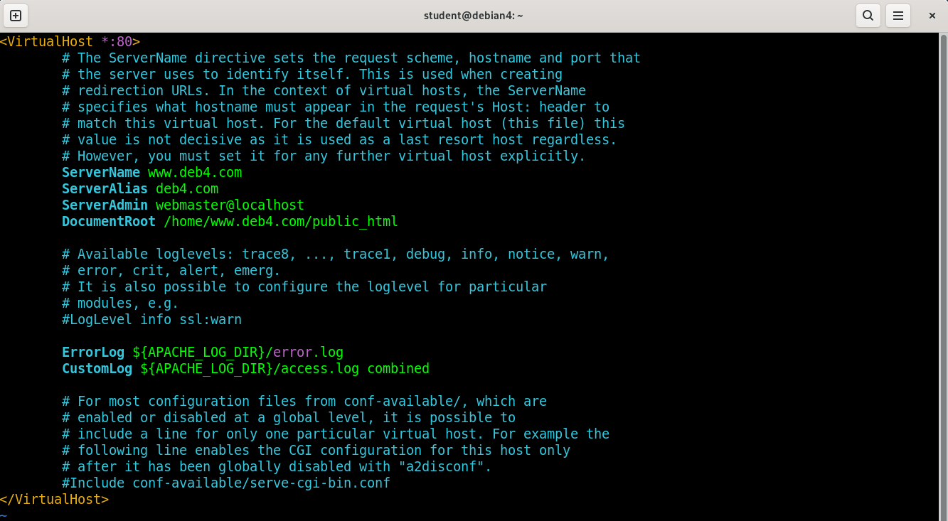
Step 29: Provisions for the Web System User
Run mkdir public_html in the skell directory to build the required directory layout framework, and execute adduser www.deb4.com --force-badname to provision the system user profile and account credentials.
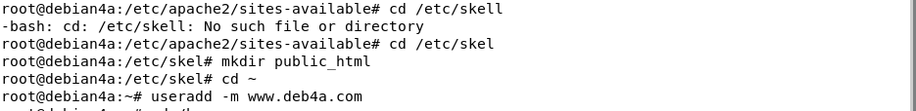
Step 30: Modifying User Home Folder Security Flags
Inspect the existing home file systems layout by executing ls -l /home. Update the system boundary parameters by running chmod 755 www.deb4.com to grant outer processes the lookup privileges needed to parse target site elements.
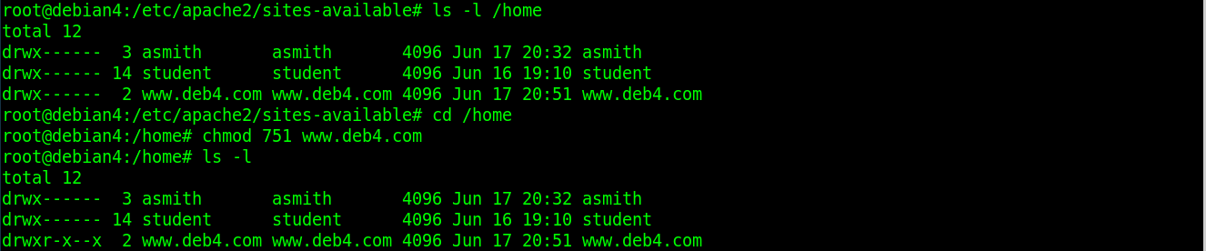
Step 31: Building the Main Web Landing Page
Grant open access privileges to your directory structure temporarily by executing chmod 777 public_html/. Switch context to the site administrator profile by running su www.deb4.com, move inside the public folder, and open vim index.html to compose your baseline home page document. Write Welcome inside and save it.
Step 32: Registering the New Site Profile
Return to your root shell context and run a2ensite 001-deb4.com.conf to register your new virtual domain map inside the web engine. Run command systemctl reload apache2.
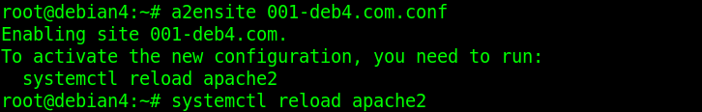

Step 33: Implementing Directory Control Context Blocks
Re-open your custom profile definition vim /etc/apache2/sites-available/000-deb4.com.conf Copy and paste to end of the file:
<Directory /home/www.deb4.com/public_html>
Options Indexes FollowSymLinks
AllowOverride None
Require all granted flags
</Directory>

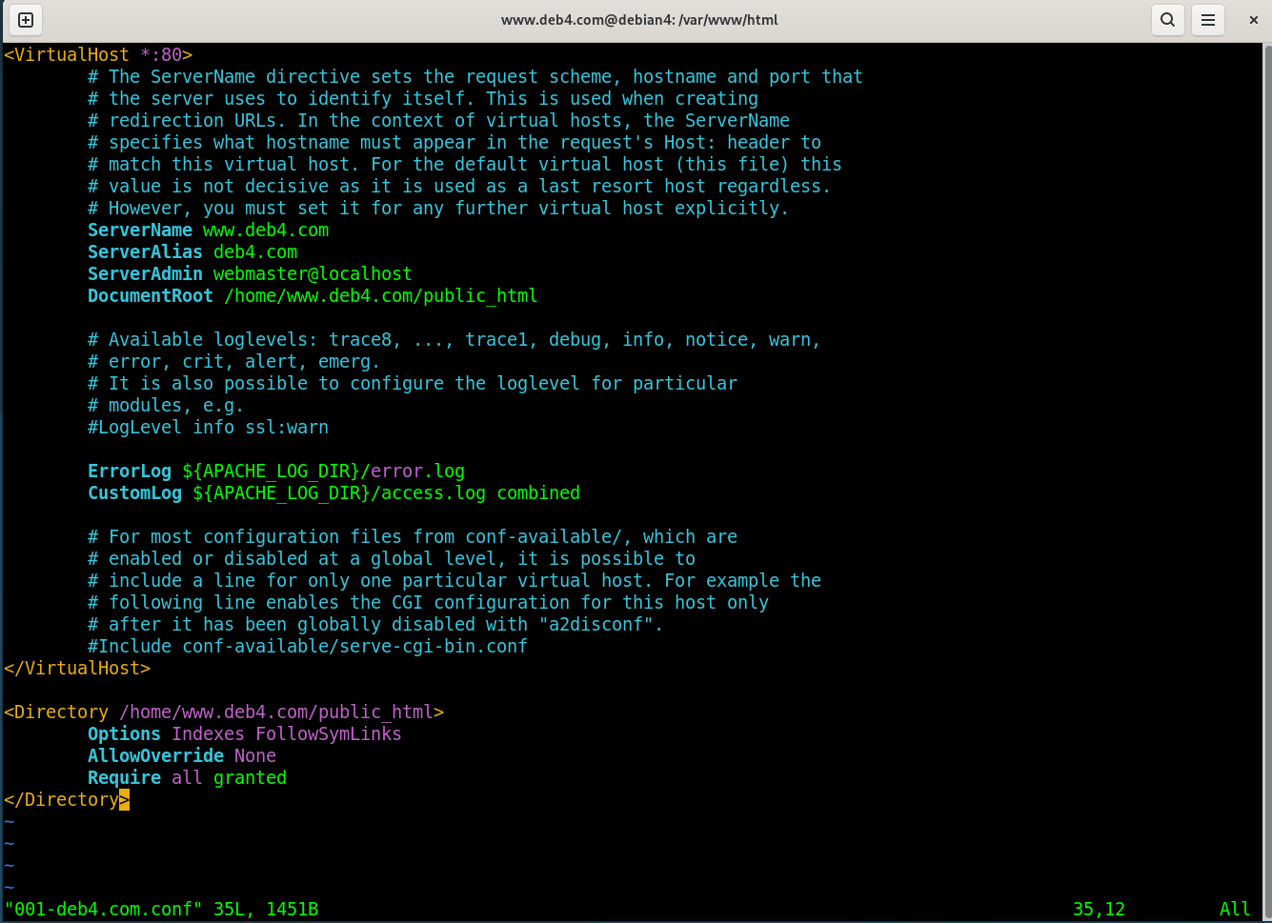
Step 34: Validating Web Platform Operational Status
Apply by executing systemctl reload apache2. Verify that your server processes are running error-free without interruption by running systemctl status apache2
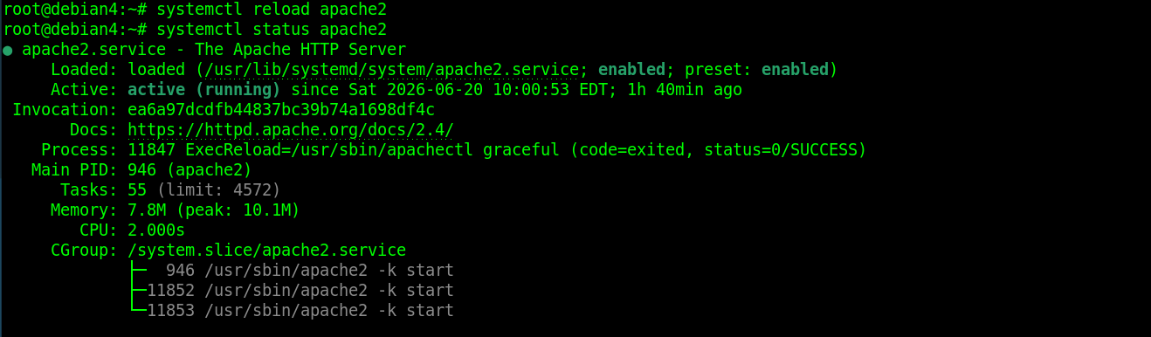
Step 35: Setting Up Final File Permissions
Confirm the html file has right permissions with chmod 751 index.html inside the public_html directory.
Step 36: Installing the Lynx Text-Based Web Browser (optional)
Run the command apt-get install lynx inside your console session. This installs a lightweight, command-line web browser that allows you to easily verify and test local network web server performance directly from your terminal.
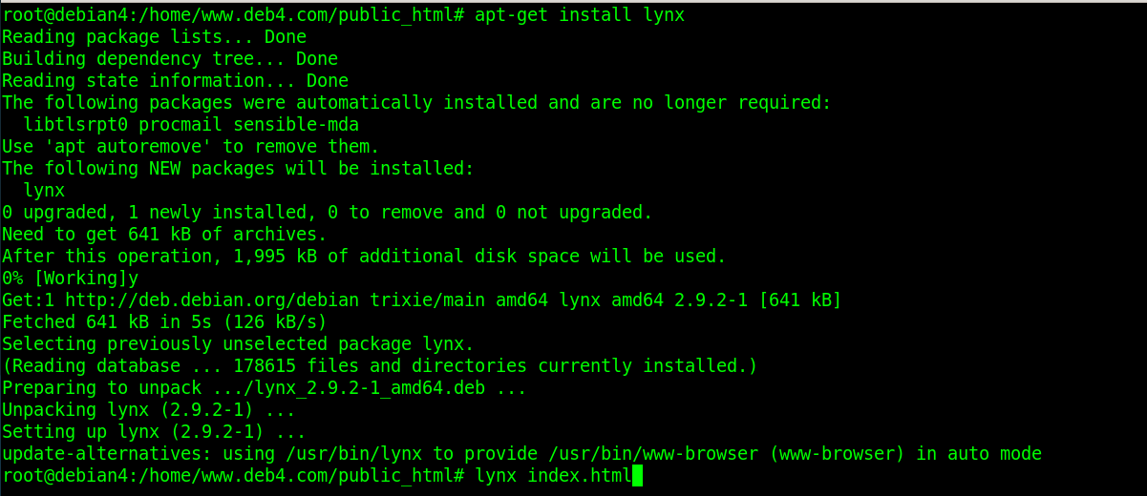
Step 37: Verifying Site Access via Lynx
Launch the command-line browser by executing lynx index.html inside your document root. Ensure that your pre-configured landing page text renders flawlessly on screen without structural warnings or visibility access errors.
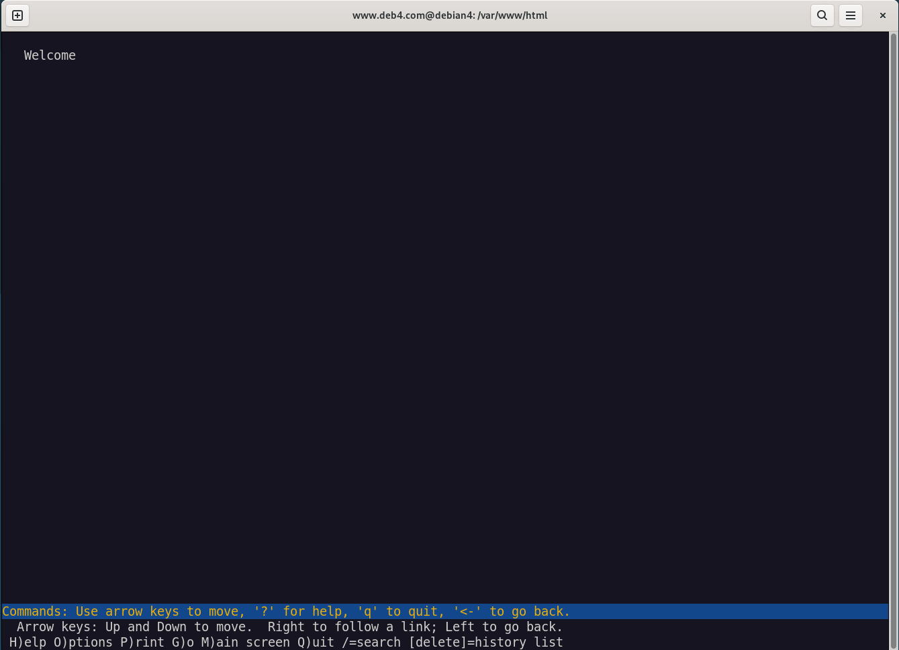
Step 38: Installing the MariaDB Database Server
Initialize your backend server database engine components by running the command apt-get install mariadb-server.
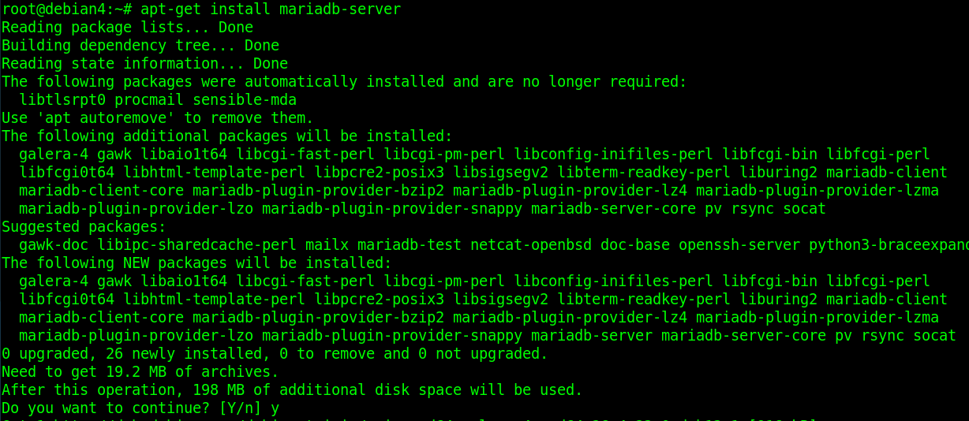

Step 39: Initiating the Automated Database Security Script
Execute the security utility string by running mariadb-secure-installation to close down systemic security gaps. Type your root password than answer like the picture for the subsequent questions.
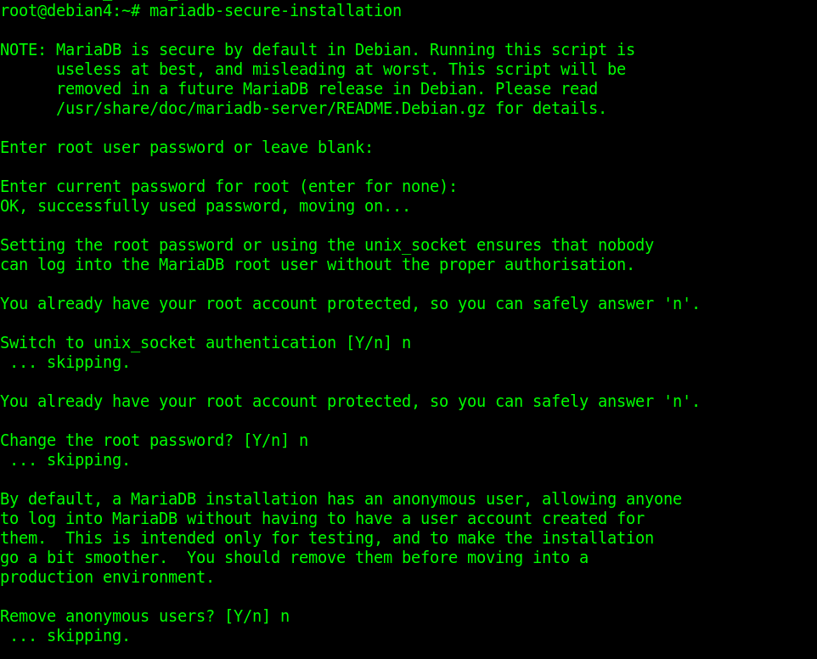
Step 40: Finalizing MariaDB Database Protections
Complete as the picture.
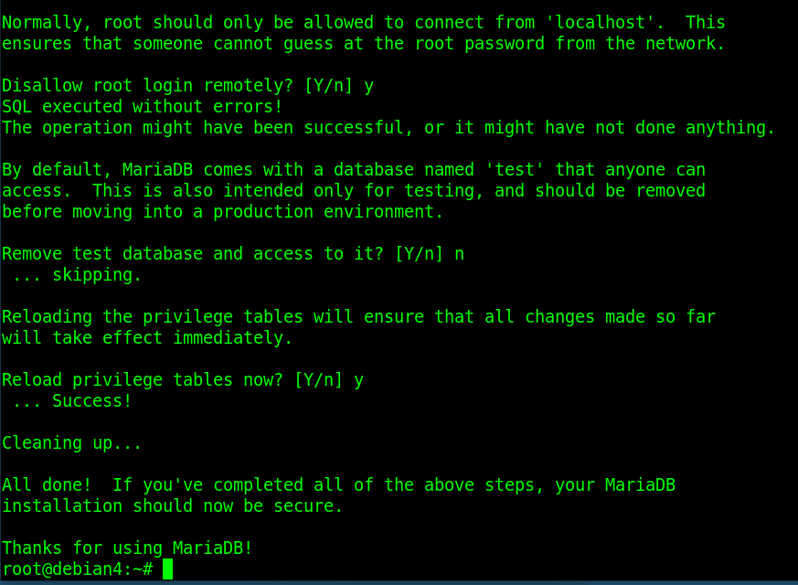
Step 41: Installing PHP Core Packages and Apache Modules
Deploy your web scripting application framework layers by entering apt-get install php libapache2-mod-php php-mysql.
Step 42: Initializing the PHP Diagnostic Environment File
Switch context back into your target user path framework and access the public directory block. Open your text editor by typing vim info.php in the same page of the index.html file.
Step 43: Writing the PHP Diagnostic Test Script
Get Inside your text editor typing vim /home/www.deb4a.com/public_html/info.php to create info.php, insert the standard diagnostic block script:
<?php
phpinfo();
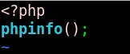
Step 44: Launching the MariaDB Command Line Shell
Return to your console session and type mariadb to open up the interactive MariaDB monitor shell.
Step 45: Provisioning the Project Database
Create a data base using CREATE DATABASE deb4; and press enter to create the database architecture.
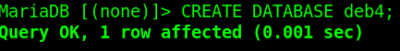
Step 46: Generating a Remote Database User Profile
Provision a separate user credential profile to delegate database storage permissions securely without exposing root credentials. Run the query CREATE USER 'deb4'@'%' IDENTIFIED BY 'Amf123456'; to create an account that can connect from any network IP interface.
Step 47: Allocating Database Object Permissions
Grant full-operation privileges on your newly established schema to your remote user profile. Execute the query GRANT ALL ON deb4.* TO 'deb4'@'%'; and to give the user complete access to create, read, update, and delete objects inside the schema container.
If get an permission error to run the code, reopen Mariadb using the command sudo mariadb -u root
Step 48: Applying Database Privilege Updates
Reload the active internal server lookup tables to commit your new user account and permission grants to memory immediately. Execute the statement FLUSH PRIVILEGES;
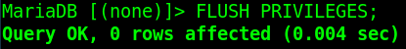
Step 49: Validating Local User Shell Credentials
Exit your administrative root database monitor session and test your newly created user profile. Run the terminal authentication command mariadb -u deb4 -p and provide your configured user password to verify that the profile logs into the SQL shell successfully.
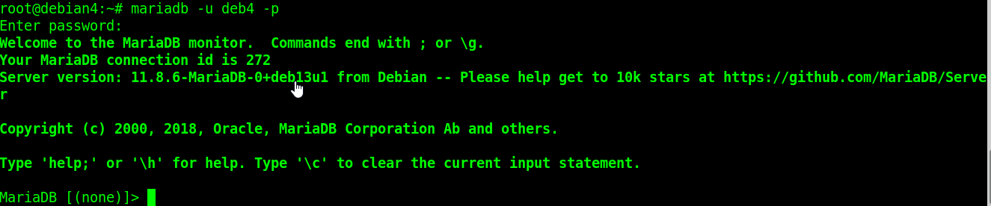
Step 50: Initializing Database App Tables and Dummy Data
Execute a query to create your structure framework by entering CREATE TABLE deb4.todo_list ( item_id INT AUTO_INCREMENT, content VARCHAR(255), PRIMARY KEY(item_id) );. Follow this by running INSERT INTO deb4.todo_list (content) VALUES ("My first important item"); and verify the data write with a quick SELECT * FROM deb4.todo_list; query.
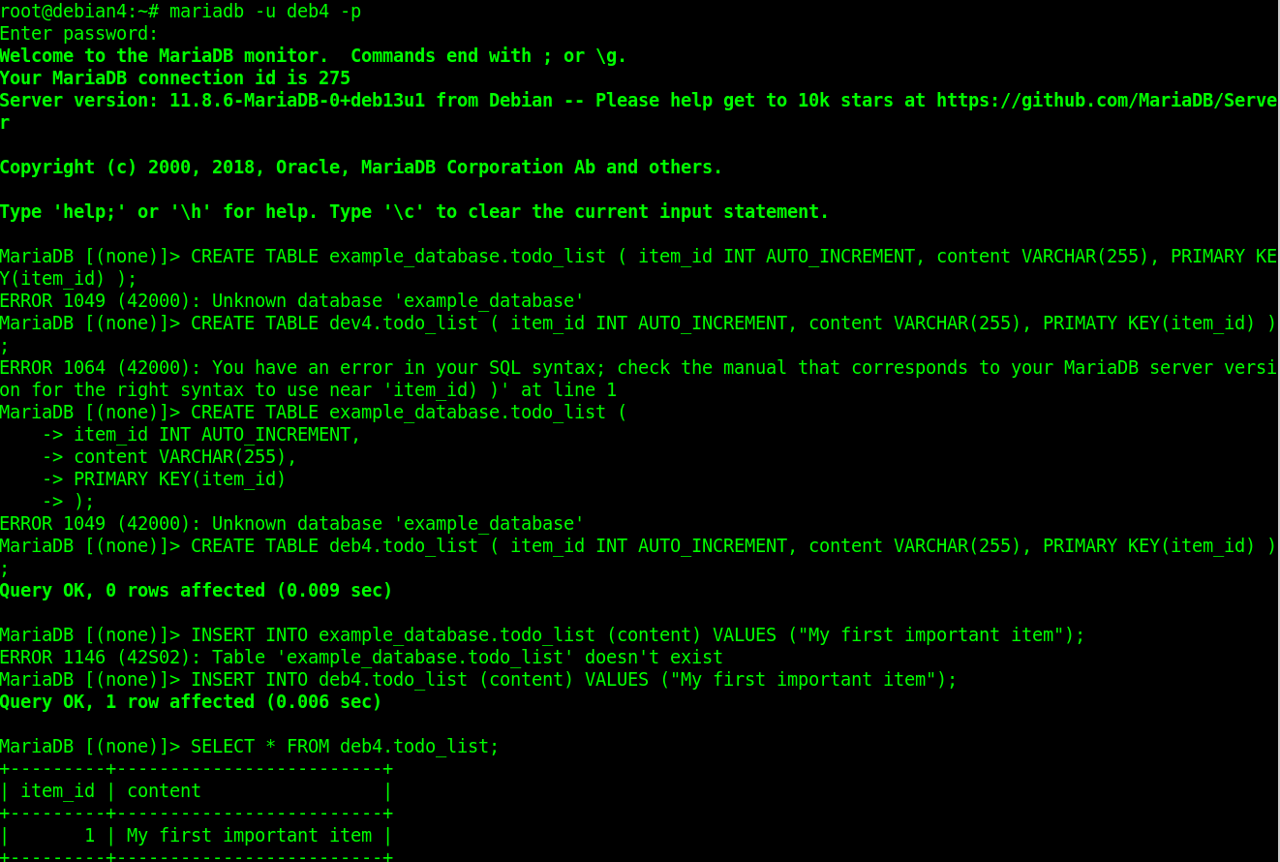
Step 51: Accessing the Web Application Target Path
Run the command vim /home/www.deb4.com/public_html/todo_list.php
Step 52: Composing the Dynamic PHP Web Application Script
Write a database collection script to extract and parse your database inputs automatically to the client browser framework.
<?php
$user = "deb4";
$password = "Amf123456";
$database = "deb4";
$table = "todo_list";

try {
$db = new PDO("mysql:host=localhost;dbname=$database", $user, $password);
echo "<h2>TODO</h2><ol>";
foreach($db->query("SELECT content FROM $table") as $row) {
echo "<li>" . $row['content'] . "</li>";
}
echo "</ol>";
} catch (PDOException $e) {
print "Error!: " . $e->getMessage() . "<br/>";
die();
}
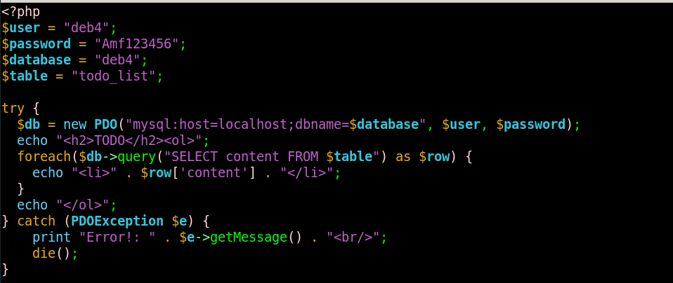
Step 53: Validating Dynamic Database Web Application Delivery
Launch an external web browser and type http://www.deb4.com/todo_list.php and verify that your SQL dummy list data outputs to screen seamlessly.
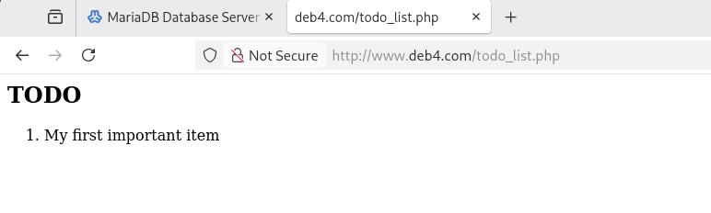
Samba
Step 54: Installing the Samba File Sharing Suite
Run apt-get install samba to install it.
Step 55: Creating Samba User Profiles and Registering Config Files
Run smbpasswd -a www.deb4.com and declare secure access profile passwords.
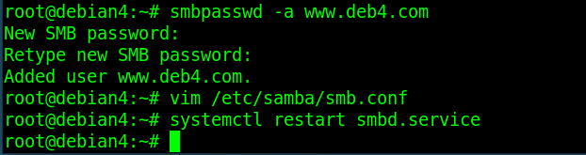
Step 56: Structuring Custom SMB Storage Share Blocks
Next, access your global parameters template file by executing vim /etc/samba/smb.conf and apply any final settings.
Append a new, isolated custom share header target string labeled [share1]. Populate the control directives list immediately below by explicitly declaring:

path = /home/www.deb4.com
setting read only = no
guest = no
valid users = www.deb4.com

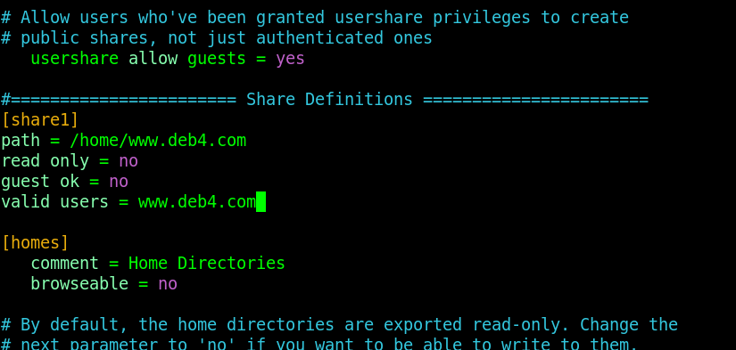
Step 57: Restarting Storage Sharing Daemons and Validating Mount Paths
Run systemctl restart smbd.service. Switch to an external network workstation client machine, access the file browser utility explorer address line framework, type out your server IP string block \\10.173.104.2, and check that your directory layouts mount without error.
